Portfolio Evidence Context Statement

Overview
This template has been designed for apprentices who are presenting a portfolio of evidence as part of their end-point assessment.
Your portfolio of evidence is expected to include examples of work you have completed, such as reports, projects, presentations and email exchanges. It is useful to also provide written narratives which provide context to the evidence you have submitted. These ‘context statements’ allow you to explain what you did, when you did it and what the results were.
You may devise your own context statements to provide this narrative, or you may choose to use this template. It is advised that you take an approach similar to the SAR method:
- Situation – outline the specific situation/issue that you dealt with
- Action – detail the specific actions you took
- Result – explain the result of your actions

Supporting evidence
Your context statements must always be supported with product evidence which authenticates your account of what took place. Please refer to your DSW Toolkit and Portfolio Requirements documents for more information on the types of product evidence you should include.
You may also wish to include a witness testimony from your line manager to accompany your context statement. This can be a written or recorded statement which corroborates your account and explains what was observed from their point of view. DSW’s Portfolio Requirements document also provides further advice around the use of witness testimonies.

Mapping your evidence
It is essential that you map your context statement to specific assessment criteria that are covered by your portfolio of evidence. Your DSW Toolkit contains a Portfolio Referencing Table which lists these criteria and allows you to indicate where they are covered within your context statement (for example, ‘Page 2, paragraph 5’).
You should also use the ‘Assessment Criteria’ column in your context statement to indicate where you believe you have covered specific criteria.

Template
Section | Description | Assessment criteria
Situation: Give a brief description of the situation you were involved in. This may have been a problem or issue, or it may have been a routine piece of work where you feel you have demonstrated competence against the relevant assessment criteria. | 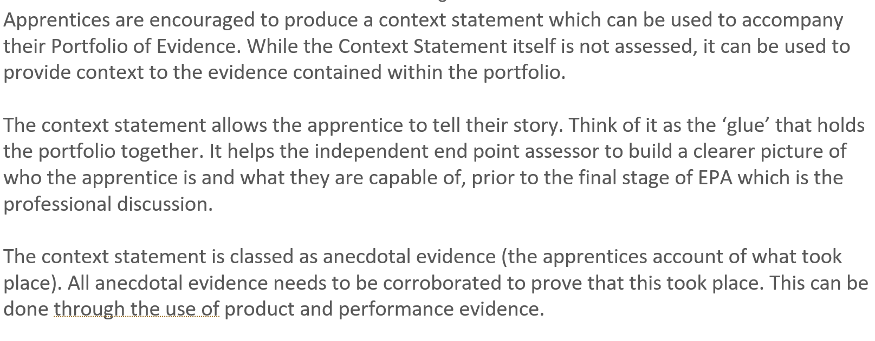
Action: Describe the actions you took to deal with the situation. It is important that your account describes your own contribution and not that of others, so avoid using terms such as ‘we’ or ‘us’. Your account should include:  - Who was involved  - When the activity took place  - Actions you undertook (supported by evidence – please refer to DSW’s Portfolio Requirements document)  - Examples of performance against the specific assessment criteria for this method | 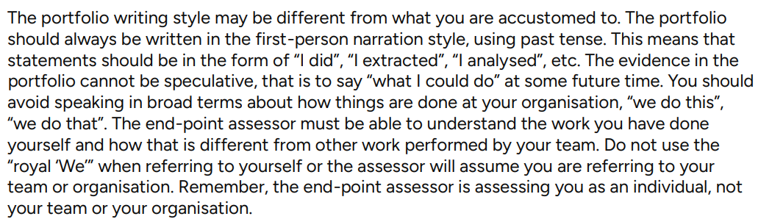
Result: Describe what the results were of your activity.

Supporting Evidence
You may add screenshots or embedded documents in the space below, or you may include these in a separate folder. If using a separate folder, please ensure that documents are clearly listed and labelled using the space below.

