




HR Support
Level 3
Toolkit




Contents
Introduction 2
Gateway 2
End-Point Assessment Overview 3
Timeline 3
Planning Meeting 4
Conditions for Assessment 4
Mapping and Amplification 4
Project Plan 5
Consultative Project 5
Professional Discussion 6
Assessment method grading 7
Overall grading 8
Resits and retakes 9
Appendix I – Supporting Documents 10
Appendix II – Toolkit Updates 11

Introduction
DSW have been appointed to conduct end-point assessment (EPA) for this apprenticeship. This Toolkit has been created to help the apprentice, training provider and the employer to understand what is needed to successfully complete EPA for this standard.

All approved end-point assessment organisations must carry out EPA in line with the assessment plan published by Skills England. The assessment plan details the assessment methods used, the criteria to be assessed and the environment in which the assessments must take place.

The requirements and content of this Toolkit come directly from the HR Support assessment plan, with additional clarification provided by the external quality assurer (EQA) for this apprenticeship standard. Published assessment plans are available on the Skills England website: https://skillsengland.education.gov.uk/apprenticeships/

Gateway
Apprentices must be on programme for a duration in line with Department for Education requirements before they come through gateway and enter the EPA phase of the apprenticeship. The apprentice, employer, and training provider must agree that the apprentice is demonstrating competence against the knowledge, skills, and behaviours of the standard.

Once an apprentice is ‘gateway-ready’, the training provider must submit the following to DSW’s epaPRO portal for approval:

- Gateway Declaration
- proof of Level 2 English and maths*

*DfE exemption rules apply

More information on acceptable gateway evidence and the forms to be submitted can be found on epaPRO under Support Materials > Gateway Documents.

If any of these requirements are not met, gateway will not be approved.

It is strongly advised that the apprentice’s Project Plan template is completed and ready to be reviewed by the independent end-point assessor (IEPA) when the gateway documents are submitted. More information is available in the Project Plan section.

End-Point Assessment Overview
The HR Support EPA consists of two assessment methods:

- Consultative Project
- Professional Discussion

The apprentice must also complete a Project Plan template which is submitted after gateway and must be reviewed by the IEPA prior to work commencing on the Consultative Project. The Project Plan does not contribute towards the grading.

The standard is made up of 33 learning outcomes. The Mapping and Amplification document, which can be found in Appendix I, details the specific criteria which must be met for apprentices to meet and exceed each learning outcome.

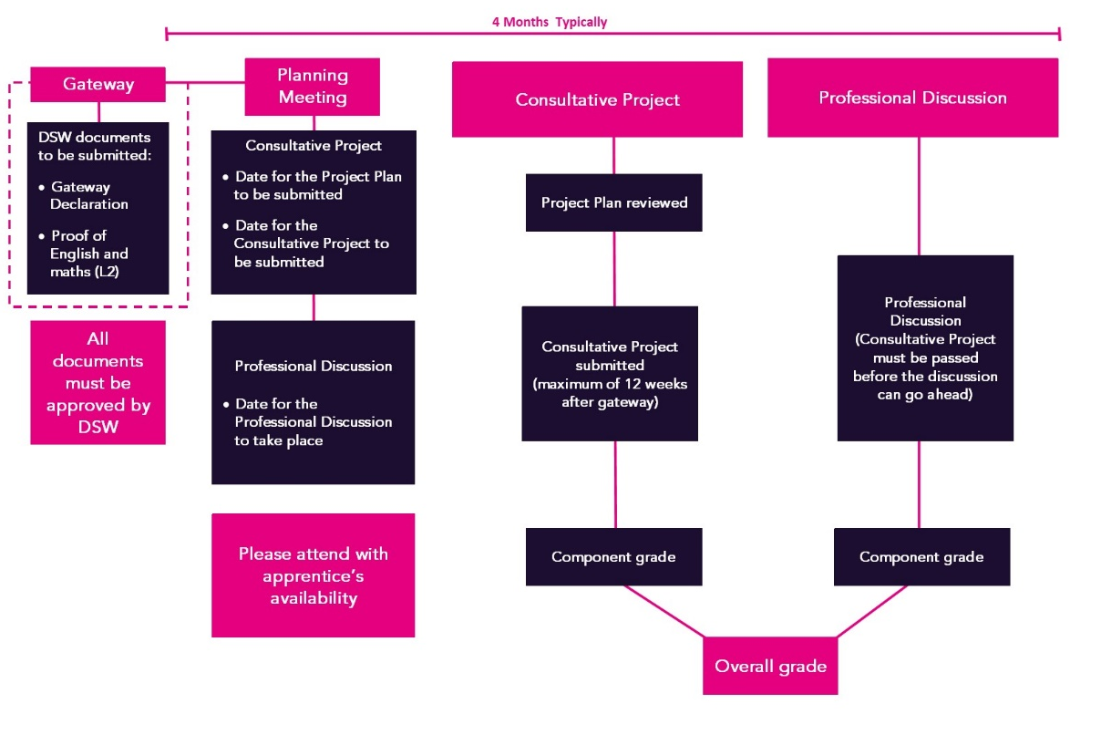
Timeline

Planning Meeting
Following gateway approval, DSW’s IEPA will contact the training provider to introduce themselves and arrange a planning meeting. Apprentices and employers are permitted to join the planning meeting if they request to do so.

During the planning meeting, the following key dates will be agreed:

Project Plan
- Date for the Project Plan to be reviewed by the IEPA.

Consultative Project
- Date for the Consultative Project to be assessed.

Professional Discussion
- Date for the Professional Discussion to take place.
- The Consultative Project must be passed before the Professional Discussion can go ahead.
- Strongly recommended to be arranged at least 10-working days after the Consultative Project assessment date.
- This allows ample time for the apprentice to prepare following the Consultative Project feedback.

The assessments will be conducted virtually via the online video conferencing platform Microsoft Teams. Others, such as Webex or Zoom can be used if preferred. Face-to-face assessments can be accommodated should the apprentice prefer. This should be discussed with the training provider and agreed with DSW. Additional costs will apply.

The IEPA will record the agreed submission and assessment dates in epaPRO once the planning meeting is complete.

Conditions for Assessment
All assessments must be taken under examination conditions. It is essential that apprentices familiarise themselves with the Conditions for Live Assessment. The document sets out the mandatory requirements to ensure a secure and appropriate assessment environment, including apprentice ID requirements, panning of rooms and appropriate use of technology.

Failure to comply with the conditions for live assessment may result in delayed, cancelled or failed assessments.

Mapping and Amplification
The Amplification document outlines what the apprentice will be assessed against in each assessment method.

The apprentice’s competence will be assessed against the learning outcomes during end-point assessment.

Amplifications are written to expand on the learning outcomes. There is also additional guidance showing how apprentices may demonstrate the learning outcomes in their Consultative Project.

Project Plan
Prior to starting the project, the apprentice must complete the Project Plan template which outlines the scope of their project, including the key goals and objectives. The purpose of this is to lay the groundwork for the project so the apprentice, with support from the training provider and employer, can ensure it has the scope to cover off all the learning outcomes and be completed within 12 weeks of gateway approval. The recommended maximum wordcount for the Project Plan is 1,000 words.

The mind map, which can be found in the Project Support document in Appendix I, has been designed to support the apprentice, the training provider and the employer to ensure the project topic has the scope to demonstrate all the required learning outcomes.

Due to the strict timescales associated with the completion of the Consultative Project, it is recommended that apprentices complete their Project Plan template in full by the time their gateway documents are submitted to DSW for approval.

The apprentice should detail how they intend to meet the learning outcomes through the Consultative Project.

Apprentices must use the Project Plan template and submit it to DSW so the IEPA can review it on the date agreed during the planning meeting. The IEPA will provide feedback on the Project Plan via an Assessment Record within five working days. Once the Project Plan has been reviewed and feedback has been received, the apprentice may start work on their project.

The Project Plan does not contribute towards the grading of this EPA. This component will be marked as ‘Reviewed’ on epaPRO.
Tip – Make use of the Mapping and Amplification document and Referencing Table to ensure the Consultative Project has the scope to meet all the required learning outcomes.
There is also a Project Guidance document in Appendix I to support apprentices with planning, carrying out and writing up their Consultative Project.

Consultative Project
The Consultative Project will allow the apprentice to reflect on a real example of work done in their role. The project must be started and completed after gateway once the Project Plan has been reviewed by the IEPA. The apprentice must submit their Consultative Project within 12 weeks of gateway.

The project should showcase how the apprentice used their acquired knowledge and HR-related skills to deliver the service required by their role.

Examples of typical projects might include:

- Providing advice/guidance to a manager/team on a range of HR matters from recruitment through to retirement.
- Taking a defined role in a larger project run by more senior members of the HR team.
- Carrying out analysis of HR information and producing recommendations for action.

The main output for the project is a project report with a maximum word count of 3,300 words. Should an apprentice submit a report above the word count, the assessment will still be carried out with anything over 3,300 words being disregarded.

The project report must be supplemented by product and performance evidence which authenticates the apprentice’s account. This may include emails, reports, minutes from meetings or project documentation. The apprentice must comply with data protection legislation as well as redacting any commercially sensitive information where appropriate.

The purpose of appendices and evidence is to provide further context and to evidence what is written within the project report. Therefore, appendices cannot be used to solely demonstrate a learning outcome.

Further guidance on the Consultative Project can be found in the Project Guidance document, which can be found in Appendix I, and in DSW Evidence Requirements.

The apprentice may choose to submit their project using the Project Report Template, which can be found in Appendix I. This includes an example of the report structure which could be used.
Tip – Make use of the Mapping and Amplification document in Appendix I to ensure all learning outcomes have been demonstrated in full.
Ensure to include product and performance evidence and refer to this throughout the report. This will give the IEPA further context to the apprentices’ report and will bring the work they have done to life.

Referencing the Consultative Project

Before submitting their final Consultative Project for assessment, the apprentice must complete the Referencing Table in Appendix I. This table, which includes instructions on how to complete it, is used to indicate which sections of the report and supporting evidence demonstrate each of the learning outcomes. All learning outcomes must be mapped to the project report.

The project report should also be referenced to make it clear which sections meet which learning outcomes; this can be done by listing the learning outcome reference numbers at the end of each paragraph.

Once complete, the project and Referencing Table must be uploaded to epaPRO for assessment. Feedback will be provided via an Assessment Record and may detail up to three learning outcomes which have not been fully met by the project report. These outcomes will be carried over to the Professional Discussion.

In the event four or more learning outcomes are not fully met in the Consultative Project, the assessment method will be graded as a fail. No learning outcomes will be identified at this stage to be carried over to the Professional Discussion.

The Consultative Project must be passed before the apprentice can attempt the Professional Discussion.

Professional Discussion
The Professional Discussion is a structured dialogue between the apprentice and the IEPA, designed to establish the apprentice’s understanding and application of the knowledge, skills, and behaviours.

The purpose of the discussion is to:

- explore the 13 learning outcomes which are assigned to the Professional Discussion.
- explore up to three learning outcomes which were not met in the Consultative Project. These will be detailed in the Assessment Record following the assessment of the Consultative Project.
- build a cumulative picture of performance against the standard.
- explore evidence of exceeding the learning outcomes.

The discussion will take place in a suitable environment and will normally last between 60 and 75 minutes. The IEPA will ask the apprentice 13-16 core questions about their work and the way they have applied themselves to certain tasks. The IEPA may also use follow up questions to prompt for further detail.

The Professional Discussion is not solely based on the Consultative Project, so apprentices may use any work-based examples from the apprenticeship period in their responses.
Tip – Apprentices may find it helpful to use STAR to frame their responses:
Situation: Describe the situation and when it took place
Task: Explain the task and the goal
Action: The action(s) they took to achieve the goal
Result: Explain the result of their actions

The discussion will be held via an online video conferencing platform as decided during the planning meeting. It is strongly recommended that the platform is tested prior to the date of assessment. Please refer to DSW Conditions for Live Assessments.

Assessment method grading

Learning outcome grading
There are 20 learning outcomes assigned to the Consultative Project. Up to three learning outcomes which are not fully met through the Consultative Project may be covered in the Professional Discussion.

There are 13 learning outcomes assigned to the Professional Discussion. This does not include any learning outcomes which may be carried over from the Consultative Project.
The table below shows the grading for each learning outcome. To enable grade aggregation, each learning outcome can only be scored as 0, 1, 3, or 5. The Mapping and Amplification document, which can be found in Appendix I, details the evidence required to meet and exceed each learning outcome.
Grade | Marks | Description
Not met | 0 | The apprentice has not provided any evidence to sufficiently demonstrate the learning outcome.
Partially met | 1 | The apprentice has provided evidence which demonstrates some of the learning outcome.
Met | 3 | The apprentice has provided evidence which demonstrates full competence against the learning outcome.
Exceeded | 5 | The apprentice has provided evidence which significantly exceeds the learning outcome.

Consultative Project grading
A minimum of 17 and a maximum of 20 learning outcomes will be assessed through the Consultative Project.

- A fail will be awarded if four or more learning outcomes are scored below 3.
- To achieve a pass, the apprentice must achieve a score of 3 or more in at least 17 learning outcomes.
- To achieve a distinction, the apprentice must meet the pass criteria and achieve an overall score of at least 85% of the available marks.

For clarity, the table below shows how many marks you must achieve for pass and distinction based on the number of learning outcomes which are being assessed:
Learning outcomes assessed | 17 | 18 | 19 | 20
Maximum points available | 85 | 90 | 95 | 100
60% threshold (pass) | 51 | 54 | 57 | 60
85% threshold (distinction) | 73 | 77 | 81 | 85
Number of learning outcomes required at 5 to achieve distinction | 11 | 12 | 12 | 13

Professional Discussion grading
A minimum of 13 and a maximum of 16 learning outcomes will be assessed through the Professional Discussion, depending on the number of learning outcomes carried over from the Consultative Project.

- A fail will be awarded if any learning outcome is scored below 3.
- To achieve a pass, the apprentice must achieve a score of at least 3 in each learning outcome.
- To achieve a distinction, the apprentice must meet the pass criteria and achieve an overall score of at least 85% of the available marks.

Learning outcomes assessed | 16 | 15 | 14 | 13
Maximum points available | 80 | 75 | 70 | 65
60% threshold | 48 | 45 | 42 | 39
85% threshold | 68 | 64 | 60 | 56
Number of learning outcomes required at 5 to achieve distinction | 10 | 10 | 9 | 9

Overall grading
To achieve an overall grade of pass, the apprentice must achieve a minimum of a pass in both assessment methods.

To achieve an overall grade of distinction, the apprentice must achieve a distinction in both assessment methods.

If the apprentice fails one or more assessment methods, the maximum overall grade will be capped at a pass.

Resits and retakes
Apprentices who fail one or more assessment methods will be offered the opportunity to take a resit or a retake. A resit does not require further learning, whereas a retake does. The training provider, employer and apprentice will determine whether a retake is required. The timescales and content of the further learning will be defined to support the apprentice ahead of the retake taking place.

Apprentices should have a supportive action plan to prepare for the resit or a retake. The apprentice’s employer will need to agree that either a resit or retake is an appropriate course of action.

Resits and retakes are not offered to apprentices wishing to move from pass to distinction.

If an assessment method is failed, the maximum overall grade that can be awarded is a pass.

Consultative Project
If the apprentice fails the Consultative Project, they can amend the report in line with the IEPAs feedback. There is no maximum time period in which this must be submitted, but apprentices are encouraged to resit as soon as it is reasonably possible. This ensures the project is still fresh in their mind and they are able to access any additional supporting evidence they may wish to submit.

Alternatively, the apprentice can choose to complete a new project plan, this must be reviewed by the IEPA in advance of the project commencing. Once reviewed and feedback has been received, the apprentice can carry out their project. The apprentice has 12 weeks from the date they submitted their project plan, to submit their Consultative Project.

Professional Discussion
In the event that the Professional Discussion is graded as a fail, the discussion will need to be resat or retaken. The resit/retake will assess all learning outcomes assigned to the Professional Discussion, and up to three learning outcomes which were carried over from the Consultative Project.

Appendix I – Supporting Documents
The documents in this table have been developed specifically for the Level 3 HR Support standard.

Document | Description
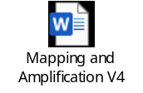 | Shows which pass and distinction descriptors need to be met through which assessment method, along with additional guidance of the evidence required.
 | This document will guide the apprentice through their Consultative Project, from identifying a suitable project, to carrying out the project activities and writing up the project report.
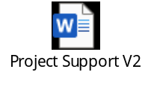 | This document provides support to apprentices in selecting an appropriate project, and in planning their project report.
 | To be completed by the apprentice to show the scope of their Consultative Project and how they intend to meet the learning outcomes. Must be submitted and signed off by the IEPA prior to work starting on the Consultative Project.
 | The apprentice may choose to use this document to present their project report. This document is not mandatory; the apprentice may choose to submit their report on their own Word or PDF document.
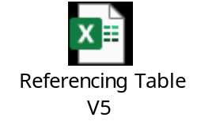 | This document must be used to map the Consultative Project, and additional evidence to each of the learning outcomes and is submitted at the same time as the Consultative Project.

Further guidance documents which you may find helpful but are not specific to the HR Support standard are available to download via the links below:

- Policies and Procedures
- Conditions for Live Assessment
- Templates:
- Witness Testimony
- Observation Record
- Technical requirements for assessment and Zoom/Webex/Teams user guides
- DSW Evidence Requirements
- AI Usage Policy
- GDPR Guidance

Appendix II – Toolkit Updates

Version 3 – August 2020
- Additional clarification added to project wordcount guidance

This change is applicable to all apprentices.

Version 4 – November 2020
- Covid flexibility document added

This change is applicable for apprentices who meet the requirements of the rules set out within the embedded dispensation document.

The below documents have been updated to reflect the changes above. The version numbers are the current ones for the documents embedded within version 4 of the toolkit.
- Covid Flexibilities for HR Support and HR Consultant Partner V1 document retired

Version 5 – November 2021
- Further guidance added regarding the project plan
- Further guidance added to the project plan template
- Resit guidance added
- Maximum wordcount for the project plan added
- Feedback to be received via an assessment record
- Amplification added to the learning outcomes document
- End date to covid flexibility amended in line with current guidance

This change will be applicable for apprentices who come through gateway on or after 1st January 2022. Apprentices who come through gateway before this date may also be assessed under this version if they will not be disadvantaged. This should be discussed with the end point assessor during the planning meeting.

The below documents have been updated to reflect the changes above. The version numbers are the current ones for the documents embedded within version 5 of the toolkit.
- Learning Outcomes and Amplification V2
- Project Proposal template V2
- Covid Flexibilities for HR Support and HR Consultant/Partner V2

Version 6 – October 2023
- Further guidance on appendices
- Further guidance on what is and what is not included in the wordcount for the Consultative Project.
- Infographic showing the end point assessment timeline added.
- Embedded documents amended in line with changes made to grading and amplification.
- Project Plan template layout improved with areas added to further support apprentices to plan their Projects.
- Clarification that the Consultative Project can be written in either first or third person.
- Grading approach changed in line with current guidance from Ofqual regarding L5 HR Consultant Partner, including distinction criteria written.

This change will be applicable for apprentices who come through gateway on or after 01/03/2024. Apprentices who come through gateway before this date may also be assessed under this version if they will not be disadvantaged. This should be discussed with the end point assessor during the planning meeting.

The below documents have been updated to reflect the changes above. The version numbers are the current ones for the documents embedded within version 6 of the toolkit.
- Mapping and Amplification V3
- Project Guidance V2
- Project Plan Template V3
- Referencing Table V3

V6.1 – November 2023
- Removed that the apprentice is limited to bringing 2 pages of notes into the Professional Discussion. Please refer to the Conditions for Live Assessments.

As this change has been designed to offer further support to apprentices and will have minimal impact, the change will take immediate effect.

V6.2 – February 2024
- The Consultative Project must be marked before the apprentice can attempt the Professional Discussion. The requirement to achieve a pass or a distinction in the Consultative Project before attempting the Professional Discussion has been removed.

This change will take immediate effect.

V7 – February 2025
- Further guidance around the timescales for retakes has been added to the resit and retake section.
- Should an apprentice submit a report outside of the given word count range, the assessment will still be carried out with anything over 3,300 words being disregarded
- Project Support document created to support apprentices to identify a suitable project and plan their project activity.
- Consultative Project Template created.
- Project Guidance document updated to provide further support to apprentices, training providers and employers.
- Signposting to DSW Project Requirements and Conditions for Live Assessments.
- Formula error fixed in the Referencing Table.

The rule regarding the word count of the project will take effect for all Consultative Projects assessed from 24/02/2025. Referencing Table V4 must be used from 01/07/2025. As the other above changes have been designed to offer further support to apprentices and will have minimal impact, they will take immediate effect.

The below documents have been updated to reflect the changes above. The version numbers are the current ones for the documents embedded within version 7 of the Toolkit.
- Project Support V1
- Project Report Template V1
- Project Guidance V3
- Referencing Table V4

V8 – October 2025

Policy updates
- Reference to Institute for Apprenticeships and Technical Education replaced with Skills England.
- Department for Education exemptions added to gateway requirements.
- Reference to DSW Project Requirements replaced with DSW Evidence Requirements.

These changes have been updated to be in line with current policies and will take immediate effect from 10/10/2025.

Process updates
- Apprentices must pass the Consultative Project before progressing to the Professional Discussion, this is to be line with the below update.
- The process of the learning outcomes carried from the Consultative Project to the Professional Discussion has been updated:
- the apprentice will no longer select up to three learning outcomes to be carried over at the project plan stage. The reference to this has been removed throughout the Toolkit.
- up to three learning outcomes which have not been fully met during the Consultative Project will be carried over to the Professional Discussion.
- any learning outcomes to be carried over will be noted on the Assessment Record.
- if four or more learning outcomes are not fully met in the Consultative Project, the assessment method will be graded as a fail.

Document updates
The below documents have been updated to reflect the changes above. The version numbers are the current ones for the documents embedded within version 8 of the Toolkit.

- Mapping and Amplification V4
- further guidance added to support the apprentice’s application of the learning outcomes to their project.
- suggested evidence the apprentice can use has been detailed against the learning outcomes.
- Project Support V2
- suggested sections ‘my organisation’ and ‘my role’ have been added the report structure.
- Project Guidance V4
- removed the reference to apprentices carrying three learning outcomes at the Project Plan stage.
- suggested sections ‘my organisation’ and ‘my role’ have been added the report structure, with the learning outcomes which could be demonstrated in these sections.
- Project Plan V4
- removed the reference to apprentices carrying three learning outcomes at the Project Plan stage.
- further guidance added to support the apprentice in completing the plan.
- Referencing Table V5
- reflects the update to the Mapping and Amplification document.
- apprentices are to only complete Column F on the Consultative Project tab.

Updated documentation effective from
As the changes to the Mapping and Amplification, Project Support and Project Guidance documents have been designed to offer further support to apprentices it is strongly advised for the apprentice to use these documents with immediate effect from 13/10/2025.

The Project Plan V4 and Referencing Table V5 must be used from 03/11/2025. However, as the changes to these documents have been designed to offer further support to apprentices it is recommended for apprentices to use these with immediate effect from 13/10/2025.

Further support
This image details apprentices at different stages of end-point assessment, the documents they must submit, and how their assessments will be carried out.






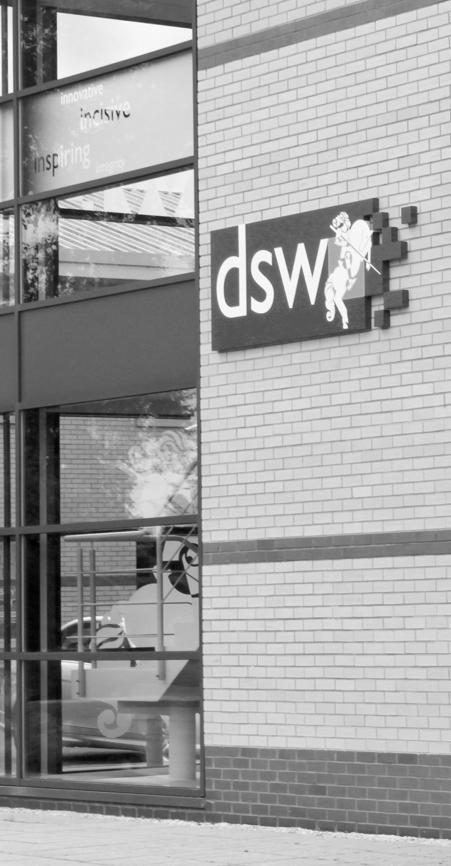
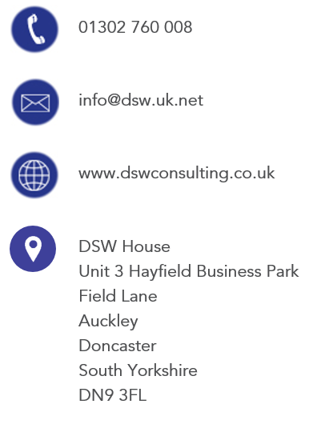
01302 760 008

epa@dswlearning.co.uk

www.dswlearning.co.uk

DSW House
Unit 3 Hayfield Business Park
Field Lane
Auckley
Doncaster
South Yorkshire
DN9 3FL

Doran Scott Williams & Co Ltd
©DSW 2025
All rights reserved. No part of this publication may be reproduced, stored in a retrieval system or transmitted in any form or by any means, electronic, mechanical, photocopying, recording or otherwise without the prior written permission of the publisher, DSW. This brochure may not be lent, resold, hired out or otherwise disposed of by trade in any binding or cover than that in which it is published, without prior consent from DSW. The law of copyright and its related rights in the UK applies and can be found in the copyrights sections in the Copyrights, Designs and Patents Act 1998 (as amended). Company Registered in England No 03803848

