





Operations or Departmental Manager - Level 5
Toolkit




Contents
Introduction 2
Key Steps 2
Grading 9
Resits and Retakes 10
Appendix I – Toolkit Updates 11

Introduction
DSW have been appointed to conduct end-point assessment for this apprenticeship. This Toolkit has been created to help the apprentice, training provider and the employer to understand what is needed to successfully complete end-point assessment (EPA) for this standard.

All approved end-point assessment organisations must carry out EPA in line with the assessment plan published by Skills England. The assessment plan details the assessment methods used, the criteria to be assessed and the environment in which the assessments must take place.

The requirements and content of this Toolkit come directly from the Operations or Departmental Manager assessment plan, with additional clarification provided by the external quality assurer (EQA) for this apprenticeship standard. Published assessment plans are available on the Skills England website: https://skillsengland.education.gov.uk/apprenticeships/

Key Steps
Pre-Gateway period – minimum of 12 months (typically 30 months)
- Delivery of on-programme training
- Delivery of Functional Skills English and maths (unless exemptions apply)
- Collection of portfolio evidence
- Decide on subject, title and scope for the project proposal.
Gateway Ready
- Employer and apprenticeship training provider (ATP) agree that the apprentice is demonstrating competence against the knowledge, skills and behaviours in the standard
- Employer confirms that apprentice is ‘gateway-ready’
- Gateway documents submitted to DSW’s epaPRO portal for approval, including proof of English and maths level 2 achievement*
- Submission of a portfolio of evidence with at least one piece of evidence mapped clearly to each pass descriptor relating to the professional discussion
- Subject, title and scope for the project proposal provided to DSW.

*Department for Education exemption apply.
End-Point Assessment period – Typically 5 months
- DSW will review the project proposal subject, title and scope and confirm if appropriate within one week of gateway approval
- The training provider continues to support the apprentice in preparing for the assessments
- There are two assessment methods that together form this EPA:
- Professional Discussion underpinned by a Portfolio of Evidence
- Project Proposal, Presentation and Questioning
- Results will be issued via email to the ATP five working days after the completion of each assessment.

End-Point Assessment Overview
The Operations or Departmental Manager EPA consists of two assessment methods:

- Professional Discussion underpinned by Portfolio of Evidence
- Project Proposal, Presentation and Questioning.

The gateway requirements include the submission of a portfolio of evidence and the subject, title and scope for the project proposal. Once gateway has been confirmed the independent end-point assessor (IEPA) will review the subject, title and scope as appropriate, or will make an alternative suggestion, within one week of gateway notification. The apprentice will have a maximum of 12 weeks to complete the project proposal from the date the subject, title and scope is agreed.

Note:
- Missing the project proposal deadline will result in a fail grade for the Project Proposal, Presentation and Questioning assessment. A new project must be completed for the resit.
- The EPA period is typically five months.
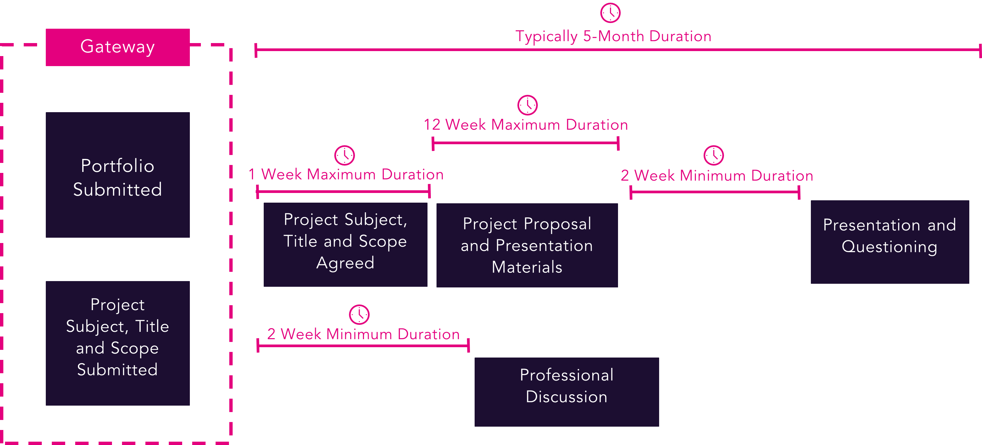
The standard is made up of 24 overarching knowledge, skills and behaviour (KSB) areas, for example ‘Communication’. These are broken down into a total of 63 individual KSB statements which form detailed pass descriptors. Apprentices must meet all of the pass descriptors to pass the apprenticeship. There are additional distinction descriptors which must all be met for apprentices to achieve a grade of distinction. Each of the KSBs is assessed by a specific assessment method and an associated pass descriptor which must be met.

The document below details the pass and distinction criteria which are assessed in each assessment method and provides amplification for each.

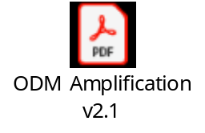

Professional Discussion underpinned by a Portfolio of Evidence

Ungraded Portfolio of Evidence
The portfolio must be compiled from the best work gathered over the on-programme stage of the apprenticeship. It will be used to support the professional discussion, but it will not be assessed or graded. The portfolio must contain at least one piece of evidence mapped clearly to each pass descriptor relating to this assessment method. Although each piece of evidence may map to more than one descriptor, this will typically result in 20 pieces of evidence to cover all required descriptors.

The portfolio will be submitted at gateway to DSW who will review the evidence and use it to help them prepare discussion points for the professional discussion. It is not graded and feedback will not be provided prior to the discussion.

A date and time for the professional discussion will be agreed following the planning meeting. Apprentices will be given at least two weeks’ notice.

The Portfolio Referencing Table embedded below provides details of each pass and distinction descriptor which is assessed through the professional discussion. The apprentice, the ATP and the employer must be confident that the portfolio provides evidence against each of the required descriptors as detailed in the attached referencing table.

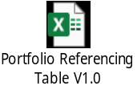

The DSW Evidence Requirements document, available for download from epaPRO, provides further guidance on the types of evidence that can be included as well as suggestions on how to ensure that the evidence is valid, authentic, reliable, current, and sufficient.

Reflective accounts or any methods of self-assessment should only be included for S8.1. It is acceptable for apprentices to include written narratives to provide context to their evidence, however, they should not contain any form of self-evaluation or self-assessment (with the exception of S8.1). Any employer contributions should focus on direct observation of performance (for example witness statements) rather than opinions.

Professional Discussion
The professional discussion is a structured dialogue between the apprentice and the IEPA, designed to establish the apprentice’s understanding and application of the KSBs that link to the professional discussion.

The portfolio of evidence can be referred to by the apprentice and the IEPA during the professional discussion. It should last for 60 minutes (+six minutes at the discretion of the IEPA); anything in excess of this will not be included in the assessment of the professional discussion.

The IEPA will prepare a minimum of six discussion points based on the evidence seen in the portfolio. These will be used to guide the discussion to ensure that all necessary KSBs and grading descriptors are covered. Each discussion point should be used to open up a free-flowing discussion and the IEPA may probe for further information as appropriate.

The discussion will be conducted virtually via the online video conferencing platform Microsoft Teams. Others, such as WebEx or Zoom can be used if preferred.

For further information regarding how the live assessment will be conducted, please refer to the DSW Conditions for Live Assessments document. This is available for download on epaPRO.

Face-to-face assessments can be accommodated should the apprentice prefer. This will have to be discussed with the training provider and agreed with DSW. Additional costs will occur. For virtual assessments, it is strongly recommended that the platform is tested prior to the date of assessment to avoid technical problems and ensure familiarity with the platform.

Following the professional discussion, the IEPA will write up their notes and will issue the final grade and feedback to the ATP. This will be done within five working days of the assessment date.

Assessment Grading
To achieve a pass in the Professional Discussion underpinned by a Portfolio of Evidence, the apprentice must meet all 12 pass descriptors which are mapped to this assessment method.

To achieve a distinction in the Professional Discussion underpinned by a Portfolio of Evidence, in addition to the pass descriptors, the apprentice must meet all six distinction descriptors which are mapped to this assessment method.

Professional Discussion – Sample Discussion Points
Below are examples of discussion points that the IEPA may have prepared to ask during the professional discussion. The assessment should be a free-flowing discussion and the IEPA may prompt to explore other descriptors (or components of) and gain further information. Examples of the type of prompt that may be asked are given under each discussion point.

Discussion Point:
‘In your portfolio, you include an example of working with your senior manager to create an operation plan for a new product launch. Can you talk me through the techniques that you used to create the plan?’

Possible prompts:
- ‘What data security did you have to consider when creating the plan?’
- ‘Have you used different techniques when working on other operational plans?’
- ‘What communication methods did you use when working with the various people involved in the product launch?’

Discussion Point:
‘What talent management model (or models) was applied when you recruited and inducted the two new store managers?’

Possible prompts:
- ‘Why did you use these models?’
- ‘What performance management techniques did you use once they were in post?’
- ‘Can you explain the leadership style or styles that you used?’
- ‘How did you explain your organisation’s vision and goals to the new staff?’

Discussion Point:
‘In your portfolio, you have included an example of leading on the implementation of a new monitoring system within your business. Talk me through the leadership styles you used to manage the different stakeholders involved’.
Possible prompts:
- ‘How did you decide which leadership style to use with the different teams/people?’
- Which communication methods did you use to share information about the new system?
- ‘How did you decide how to share the information?’
- ‘You had to collaborate with several other teams to implement the new system. How did you manage this?’
- ‘What did you do when you met resistance from colleagues?’

Project Proposal, Presentation and Questioning

Project Proposal
The apprentice must produce a project proposal over 12 weeks during the EPA period. This should be a relevant and defined piece of work that has a real business benefit, is relevant to their role and allows the relevant KSBs to be assessed by the IEPA.

The project proposal should be a detailed project implementation proposal that will enable the project to be fully implemented in the future. This will take the form of an annotated project proposal in order to allow the apprentice to fully evidence the associated grading descriptors.

The project does not need to be fully implemented during the EPA period, however, some of the project implementation should be underway to allow all demonstrations of the KSBs and the assessment descriptors to be fully evidenced. The project scope, submitted at gateway, asks the apprentice to identify how much of the project proposal will be implemented in the 12-week period.

A brief summary of the project proposal’s subject, title and scope must be submitted at gateway using the template below.



The Project Title and Scope should be no more than 500 words. Any title and scopes in excess of 550 words will be rejected on this basis. The IEPA will notify the training provider via email in such an event.

Apprentices are expected to outline:
- the nature of the project proposal and the business need it is addressing.
- the aspects of the project that will be implemented during the 12-week period.
- the tasks that will be undertaken. Who else will be involved in undertaking the project proposal and how will this be managed?

Included in the template is a section in which apprentices can map how/where they intend to provide evidence for each assessment descriptor. This mapping section is optional and down to the preference of the apprentice. Should they not wish to complete this, it is to be left blank and/or removed completely from the document.

The employer should have agreed on the proposal and ensured that it has a real business application. DSW will confirm that the subject, title and scope meet the requirements of the EPA, or will make an alternative suggestion, within one week of gateway approval. The reviewed project scope will be made available on epaPRO along with the outcome (approved or not approved).

The day the IEPA uploads the reviewed scope with their feedback/comments to epaPRO is known as the Issue Date. The beginning of the 12 weeks in which to write and submit the project proposal and presentation materials is the day after the Issue Date.

During the planning meeting, the IEPA will confirm the submission date for the proposal and presentation materials (and any supporting notes). The deadline for submission is 23:59 on the agreed date. Should the deadline be missed, then the Project Proposal, Presentation and Questioning assessment method will be graded as a ‘fail’ and a resit will be needed. A new project must be completed for the resit.

Example:

• Issue date - Monday 01st
• The start of the two-week material development period - Tuesday 02nd
• Submission of materials - 23:59 on the Tuesday 16th.

Examples of suitable projects to base the project proposal on include:
- the need to review and implement a change plan to improve efficiency within the workplace.
- the continuous improvement review of a current process, service or product to ensure it is still fit for purpose and meets the current needs of the business.
- the need to implement a direct saving (e.g. percentage decrease in direct costs, reduction in headcount) across their team, department or organisation following a reforecast activity.

The project proposal must be between 3,600 to 4,400 words. All of the assessment descriptors assigned to this assessment must be covered across the project proposal and the presentation. Apprentices should attempt to cover all required descriptors where possible so that the presentation and Q&A can be used to explore any gaps.

DSW has provided details against the grading descriptors to support apprentices in providing sufficient evidence. These can be found in the Amplification document.

The project proposal should be supplemented by product evidence which authenticates the apprentice’s account. This may include things such as emails, reports, minutes from meetings or project documentation. Apprentices must comply with Data Protection legislation as well as redacting any commercially sensitive information where appropriate.

The DSW Evidence Requirements document, available for download from epaPRO, provides further guidance on the types of evidence that can be included as well as suggestions on how to ensure that the evidence is valid, authentic, reliable, current, and sufficient.

Evidence of leadership support of the project proposal, detailing what has been implemented to date, must be included as an appendix. This could be an email, letter or other written confirmation. A template has been provided for employers to use if they wish. Leadership support will be discussed during the presentation.



Completing the Project Proposal
The Project Proposal Guidance document embedded below provides in-depth detail about how to develop the proposal and what is expected of the apprentice. It should be carefully reviewed before beginning.



The project proposal should be completed using either the template provided below or, if preferred, their own document. The final project proposal should be referenced to make it clear which sections meet which assessment descriptors. Instructions on how to complete this are included in the attached template.

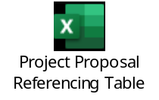

Before submitting their final project proposal for assessment, the apprentice must complete the above referencing table to indicate which sections of the project proposal and presentation meet each of the required KSBs and assessment descriptors.

Once the project proposal has been completed, it must be sent to DSW for assessment against the standard. The IEPA will assess the project proposal; no feedback can be given prior to the presentation and questioning taking place.

- If the project proposal and presentation are not submitted within 12 weeks of the agreed start date, this assessment method will be marked as a fail.
- Project proposals must be between 3,600 and 4,400 words. Any proposals under the minimum word count will be assessed as submitted. Any over the maximum will be assessed up to 4,400 words, with anything over being disregarded.​
- The word count includes tables, graphs and figures but does not include annexes or references/citations.

Presentation and Questioning
The presentation must be submitted with the project proposal. The presentation and questioning will take place at least two weeks later to allow the IEPA time to assess the submitted materials and prepare for the questioning section of the assessment.

The presentation and questioning will last for 60 minutes with an additional six minutes at the discretion of the IEPA. The presentation will typically last 20 minutes and the questioning typically 40 minutes. The IEPA will draw the presentation to a close after 30 minutes. Anything exceeding 66 minutes will not be assessed.

For further information regarding how the live assessment will be conducted, please refer to the DSW Conditions for Live Assessments document. This is available for download on epaPRO.

The presentation must cover the following points and the IEPA will have prepared a question based on each of them:

- operational management such as business tools, management systems, identifying and overcoming barriers, identifying opportunities and interpretation of data.
- project management such as using tools and techniques to plan and deliver outcomes, approaches to identifying and managing risks.
- finance such as monitoring budgets and financial implications.
- leading people and supporting management of change.
- building relationships.
- communication skills.
- managing self, such as prioritising activities and time management.
- decision making and using evaluation techniques to support the process.
- progress of the implementation of the project proposal to date.

The IEPA will also have prepared a question on the leadership support of the project proposal based on the written confirmation submitted in the proposal. The IEPA may ask up to two follow-up questions for each of the core questions to clarify their understanding.

Assessment Grading
To achieve a pass in the Project Proposal, Presentation and Questioning, the apprentice must meet all 11 pass descriptors which are mapped to this assessment method.

To achieve a distinction in the Project Proposal, Presentation and Questioning in addition to the pass descriptors, the apprentice must meet all four of the distinction descriptors which are mapped to this assessment method.

Presentation and Questioning – Sample Questions
‘Can you talk me through how you adapted your Project Proposal in light of the budget constraints you identified?’

‘In your initial research, you identified that several staff members were resistant to the changes that would be needed for your project to be successful. Can you explain how you dealt with this resistance and impact, if any, it has had on your project as you start to implement it?’

‘How have the values and ethics of your organisation affected your project proposal?’

Overall Grading
There are two graded assessment methods:

- Professional Discussion underpinned by Portfolio of Evidence
- Project Proposal, Presentation and Questioning.

Each assessment method is graded either a distinction, pass or fail as follows:

EPA Component | Fail | Pass | Distinction
Professional Discussion underpinned by Portfolio of Evidence | Pass descriptors not met. | The apprentice must meet all 12 pass descriptors which are mapped to this assessment method at pass level. | In addition to the pass descriptors, the apprentice must meet all six distinction descriptors mapped to this assessment method.
Project Proposal, Presentation and Questioning | Pass descriptors not met. | The apprentice must meet all 11 pass descriptors which are mapped to this assessment method at pass level. | In addition to the pass descriptors, the apprentice must meet all 4 distinction descriptors mapped to this assessment method.

Apprentices must achieve a minimum of a pass in both assessment methods to achieve an overall pass.

Apprentices must achieve a distinction in both assessment methods to achieve an overall distinction.

Resits and Retakes
Apprentices who fail one or both of the assessment methods will be offered the opportunity to take a resit or a retake. A resit does not require further learning, whereas a retake does.
The training provider, employer and apprentice will determine whether a retake is required. The timescales and content of the further learning will be defined to support the apprentice ahead of the retake taking place.
An apprentice who fails an assessment method, and therefore the EPA in the first instance, will be required to resit or retake any failed assessment methods only.
If the apprentice misses the submission deadline for the project proposal and presentation materials, this will result in the failure of the entire assessment method. As a consequence, they will have to undertake a new project, with a new scope being approved by the IEPA.
Should the apprentice fail the Project Proposal, Presentation and Questioning after sitting the live assessment, they will be required to amend the project proposal and presentation in line with the IEPA’s feedback. The feedback provided in the Assessment Record will outline which descriptors have been met and the apprentice, with support from the employer and/or ATP, should decide which areas of the project proposal and presentation require further work.
The apprentice will be given three weeks to rework and submit the amended project proposal and presentation materials. The IEPA will have two weeks to review the project proposal and presentation. Five days’ notice of the presentation date will be given to the apprentice.
All assessment methods must be resat/retaken within six months of the fail notification; otherwise, the entire EPA will need to be resat/retaken.
Resits and retakes are not offered to apprentices wishing to move from pass to distinction.
Where any assessment method has to be resat or retaken, the apprentice will be awarded a maximum EPA grade of pass, unless the EPAO determines there are exceptional circumstances requiring a resit or retake.

Appendix I – Toolkit Updates

Version 2.0 – December 2023
- Removal of Appendix II, all sample assessment materials have been moved to their respective assessment sections within this Toolkit.
- Removal of Portfolio Evidence guidance from Appendix I. Appendix I is now Toolkit Updates.
- Amendments to the Project Proposal Template. Use now optional.
- Addition of the Project Proposal Guidance.
- Requirement to map Project Title and Scope to the Assessment Criteria is now optional.

The below documents have been updated to reflect the changes above. The version numbers are the current ones for the documents embedded within version 2.0 of the Toolkit:
- Criteria Amplification and Mapping V2.0
- Project Proposal Guidance V1.0
- Project Title and Scope V2.0

These changes apply to all apprentices as of the 18/12/2023.

Version 2.1 – February 2024
- General spelling and grammar amends made.
- Additional guidance added to each assessment method outlining that they can be conducted face-to-face should the apprentice wish.
- Embedding of an updated Amplification following spelling and grammar amends

The below documents have been updated to reflect the changes above. The version numbers are the current ones for the documents embedded within version 2.1 of the Toolkit:
- Amplification V2.1

Version 2.2 – May 2024
- Additional guidance added around the upload of the reviewed Project Title, Subject and Scope – introduction of the ‘Issue Date’.

The amendment made applies to all apprentices as of 09/05/2024.

Version 2.3 - August 2025
- Removal of the maximum six-month EPA period.
- Removal of references to IfATE and replaced with Skills England and a new website link.
- Removal of references to ESFA and replaced with DfE.
- Additional guidance added to the Resit and Retake section.
- Project Subject, Title and Scope word count allowance added with additional process guidance.
- Clarification of the consequences of missing the project proposal and presentation submission deadline.
- Removal of the fail consequence for reports outside of the word count range.
- Signposting to DSW Evidence Requirements and DSW Conditions for Live Assessments added.

The amendments made have minimal impact on apprentices. They will take immediate effect as of 01/08/2025.






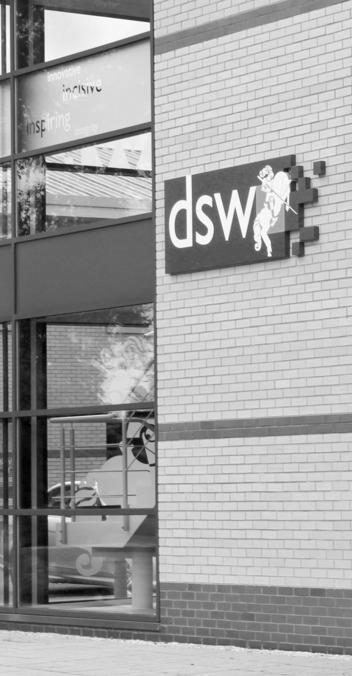
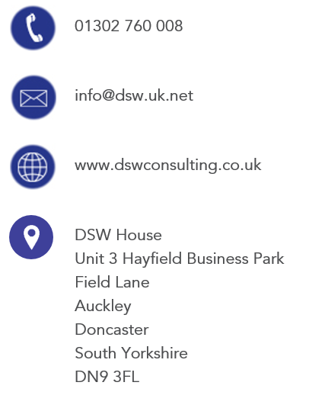
01302 760 008

epa@dswlearning.co.uk

www.dswlearning.co.uk

DSW House
Unit 3 Hayfield Business Park
Field Lane
Auckley
Doncaster
South Yorkshire
DN9 3FL

Doran Scott Williams & Co Ltd
©DSW 2025
All rights reserved. No part of this publication may be reproduced, stored in a retrieval system or transmitted in any form or by any means, electronic, mechanical, photocopying, recording or otherwise without the prior written permission of the publisher, DSW. This brochure may not be lent, resold, hired out or otherwise disposed of by trade in any binding or cover than that in which it is published, without prior consent from DSW. The law of copyright and its related rights in the UK applies and can be found in the copyrights sections in the Copyrights, Designs and Patents Act 1998 (as amended). Company Registered in England No 03803848

