




HR Support
Level 3
Toolkit




Contents
Introduction 2
What is End-Point Assessment? 2
Gateway 3
Planning Meeting 3
End Point Assessment Overview 4
Project Plan 5
Consultative Project 5
Professional Discussion 6
Assessment method grading 7
Overall grading 8
Resits and retakes 8
Appendix I – Supporting Documents 9
Appendix II – Toolkit Updates 10

Introduction
DSW is your End Point Assessment Organisation (EPAO) for this apprenticeship, and we have created this Toolkit to help the apprentice, Apprenticeship Training Provider (ATP) and employer to understand what is needed to successfully achieve End Point Assessment for this standard and complete the apprenticeship programme.

End Point Assessment (EPA) is the name given to a series of assessments an apprentice must take to prove their ability to do the job for which they have been training. The assessments take place at the end of an apprenticeship following a period of training and development, often referred to as the ‘on-programme’ period. The assessment, which accounts for 100% of the assessment of the apprenticeship.

All EPAOs must carry out End Point Assessments in line with the Assessment Plan published by the Institute for Apprenticeships and Technical Education. The Assessment Plan includes details such as the form the assessments can take, the environment in which they must be undertaken, what is to be assessed and the grading criteria. End Point Assessment must be carried out under examination conditions.

The requirements and content of this Toolkit come directly from the HR Support Assessment Plan with additional clarification provided by Ofqual, who are the External Quality Assurer for this Apprenticeship Standard. Published assessment plans are available on the Institute for Apprenticeships and Technical Education website: https://www.instituteforapprenticeships.org/

What is End-Point Assessment?
End-point assessment (EPA) is the name given to a series of assessments an apprentice must take to prove their ability to do the job they have been training for. The assessments take place at the end of an apprenticeship following a period of training and development, often referred to as the on-programme period. The assessments must be carried out by an Independent End Point Assessment Organisation and accounts for 100% of the assessment of the apprenticeship. DSW is the selected End Point Assessment Organisation for this apprenticeship.

When the on-programme phase of the apprenticeship has been completed, any required Professional and Functional Skills qualifications have been achieved and the apprenticeship training provider (ATP), employer and apprentice have agreed that the apprentice has met the on-programme requirements of the standard, the apprentice moves into the end-point assessment period.

Once the apprentice has met the gateway criteria, DSW in conjunction with the ATP, employer and apprentice will schedule in dates for each assessment in the standard. It should typically take no more than 4 months to complete this final assessment.

During the end-point assessment phase, the apprentice completes the required assessments with continued support from their employer and ATP. All assessments must be passed for the apprentice to be deemed competent.

On successful completion of all end-point assessment activities, DSW will request the apprentice’s certificate from the ESFA. This be sent to the employer’s address marked for the attention of the apprentice. It can take up to eight weeks for certificates to arrive.

Gateway
Apprentices must be on programme for a minimum of 12 months before they come through gateway and enter the End Point Assessment (EPA) phase of the apprenticeship. The apprentice, employer, and training provider must agree that the apprentice is demonstrating competence against the knowledge, skills, and behaviours of the standard.

Once an apprentice is ‘gateway-ready’, the training provider must submit the following to DSW’s EPA Pro portal for approval:
- Gateway Declaration
- Proof of Level 2 Maths and English

More information on acceptable gateway evidence and the forms to be submitted can be found on EPA Pro under Support Materials > Gateway Documents.

Once the apprentice’s gateway documents have been approved, the Independent End Point Assessor (IEPA) will make contact within two working days to arrange a planning meeting with the person listed as the on-programme assessor on the apprentice’s EPA Pro profile. The key dates associated with the end point assessment will be planned during the meeting and confirmed via email to the ATP.

It is strongly advised that the apprentice’s Project Plan is completed and ready to be reviewed by the IEPA when the gateway documents are submitted. More information is available in the Project Plan section.

Planning Meeting
Within two working days of gateway approval, DSW’s Independent End Point Assessor (IEPA) will contact the training provider to arrange a planning meeting. The IEPA will contact the person listed on EPA Pro as the apprentice’s on-programme assessor. The key dates associated with the end point assessment will be agreed during the meeting and confirmed via email to the ATP.

The planning meeting can take the form of a telephone call or email, but essentially refers to the booking and confirmation of end point assessment activities.

During the planning meeting, you will need to book in the following key dates.

Project Plan
- Date for the Project Plan to be reviewed by the IEPA.

Consultative Project
- Date for the Consultative Project to be assessed.

Professional Discussion
- Date for the Professional Discussion to take place. This will usually be arranged for 15 working days after the Consultative Project assessment date.

Please confirm if the apprentice has a preferred platform for the Professional Discussion.

End Point Assessment Overview
The HR Support EPA consists of two assessment methods:
- Consultative Project
- Professional Discussion

The apprentice must also complete a Project Plan which is submitted after gateway and must be reviewed by the IEPA prior to work commencing on the Consultative Project. The Project Plan does not contribute towards the grading.

The standard is made up of 33 learning outcomes. The Mapping and Amplification document, which can be found in Appendix I, details the specific criteria which must be met for apprentices to meet and exceed each learning outcome.

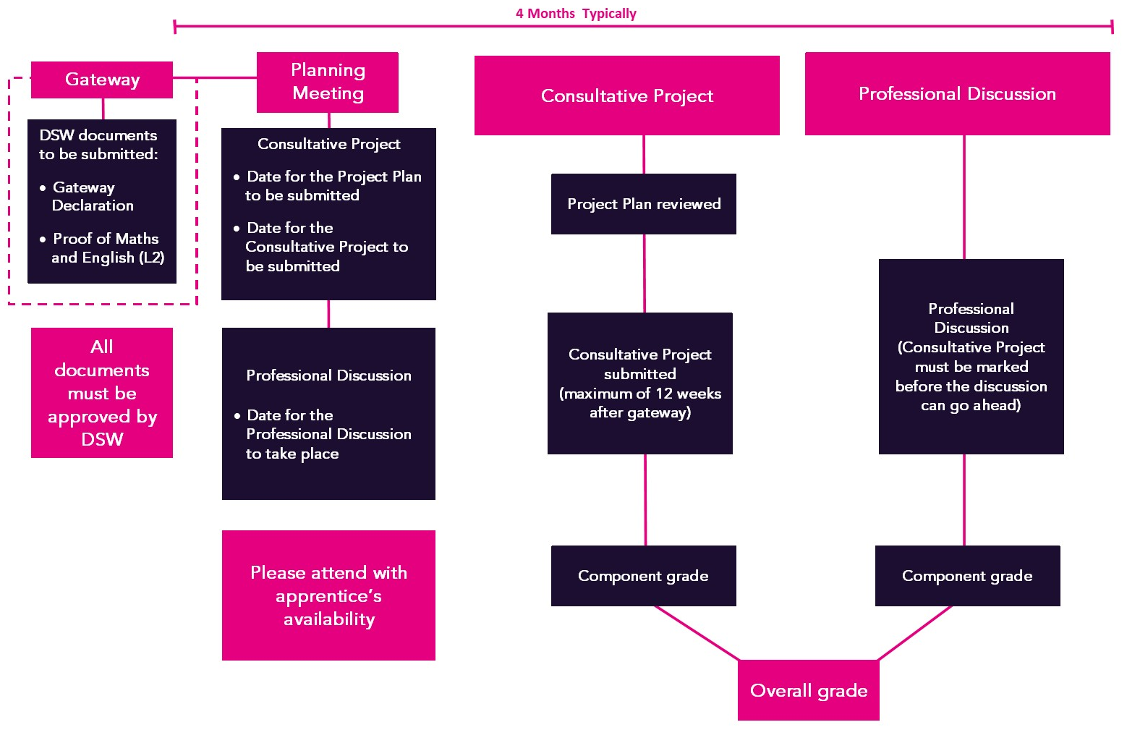
Timeline

Project Plan
Prior to starting the Project, the apprentice must complete the Project Plan template which outlines the scope of their Project, including the key goals and objectives. The purpose of this is to lay the groundwork for the Project so the apprentice, with support from the training provider and employer, can ensure it has the scope to cover off all the learning outcomes and be completed within 12 weeks of gateway approval. The recommended maximum wordcount for the Project Plan is 1,000 words.

The apprentice may choose to use the Mind Map, which can be found in the Project Support document appendix I, to support them, the training provider and the employer to ensure the project topic has the scope to demonstrate all the required learning outcomes.

Due to the strict timescales associated with the completion of the Consultative Project, it is recommended that apprentices complete their Project Plan in full by the time their gateway documents are submitted to DSW for approval.

The apprentice should detail how they intend to meet the learning outcomes through the Consultative Project. The apprentice can request to carry over up to three of the learning outcomes which cannot be demonstrated through the Consultative Project to the Professional Discussion. The apprentice will need to detail these outcomes on the Project Plan template. Once the Project Plan has been reviewed by the IEPA, it is not possible to amend the learning outcomes to be carried over.

Apprentices must use the Project Plan template and submit it to DSW so the Independent End Point Assessor (IEPA) can review it on the date agreed during the planning meeting. The IEPA will provide feedback on the Project Plan via an Assessment Record within 5 working days. Once the Project Plan has been reviewed and feedback has been received, the apprentice may start work on their project.

The Project Plan does not contribute towards the grading of this end point assessment. This component will be marked as ‘Reviewed’ on EPAPro.
Tip – Make use of the Mapping and Amplification document and Referencing Table to ensure the Consultative Project has the scope to meet all the required learning outcomes.
There is also a Project Guidance document in Appendix I to support apprentices with planning, carrying out and writing up their Consultative Project.

Consultative Project
The Consultative Project will allow the apprentice to reflect on a real example of work done in their role. The Project must be started and completed after gateway once the Project Plan has been reviewed by the IEPA. The apprentice must submit their Consultative Project within 12 weeks of gateway.

The Project should showcase how the apprentice used their acquired knowledge and HR-related skills to deliver the service required by their role.

Examples of typical projects might include:

- Providing advice/guidance to a manager/team on a range of HR matters from recruitment through to retirement.
- Taking a defined role in a larger project run by more senior members of the HR team.
- Carrying out analysis of HR information and producing recommendations for action.

The main output for the Project is a Project Report which must be 2,700 to 3,300 words. Should an apprentice submit a report outside of the given word count range, the assessment will still be carried out with anything over 3,300 words being disregarded

The Project Report must be supplemented by product evidence which authenticates the apprentice’s account. This may include emails, reports, minutes from meetings or project documentation. The apprentice must comply with Data Protection legislation as well as redacting any commercially sensitive information where appropriate.

The purpose of appendices and evidence is to provide further context and to evidence what is written within the project report. Therefore, appendices cannot be used to solely demonstrate a learning outcome.
Tip – There isn’t a template for the Consultative Project as the Projects we see are so varied, a template may potentially restrict some apprentices. This gives apprentices the freedom to present their Consultative Project in a way that best shows off the work they have completed to the IEPA. However, the Project Guidance document includes an example of the structure we typically see.

Further guidance on the Consultative Project can be found in the Project Guidance document, which can be found in appendix I, and in DSW Project Requirements.

The apprentice may choose to submit their project using the Consultative Project Template, which can be found in appendix I.

Referencing the Consultative Project

Before submitting their final Consultative Project for assessment, the apprentice must complete the Referencing Table to indicate which sections of the report and supporting evidence demonstrate each of the learning outcomes. The Referencing Table can be found in Appendix I and includes instructions on how to complete it. The Project Report must be referenced to each learning outcome, with any supporting evidence referenced to the relevant learning outcome(s).

The Project Report should also be referenced to make it clear which sections meet which learning outcomes; this can be done by listing the learning outcome reference numbers at the end of each paragraph.

Once the Project has been completed it should be sent to DSW for assessment against the standard. Following the assessment of the project, the apprentice will receive feedback via an assessment record.

The Consultative Project must be marked before the apprentice can attempt the Professional Discussion.

Professional Discussion
The Professional Discussion is a structured dialogue between the apprentice and the IEPA, designed to establish the apprentice’s understanding and application of the knowledge, skills, and behaviours.

The purpose of the Discussion is to:
- Explore the 13 learning outcomes which are assigned to the Professional Discussion.
- Build a cumulative picture of performance against the standard.
- Cover off up to three criteria where there was no opportunity to evidence in the Consultative Project (provided prior permission was agreed at the Project Plan stage).
- Explore the distinction criteria, if appropriate.

The Discussion will take place in a suitable environment and will normally last between 60 and 75 minutes. The IEPA will ask the apprentice 13-16 core questions about their work and the way they have applied themselves to certain tasks. The IEPA may also use follow up questions to prompt for further detail.

The Professional Discussion is not based on the Consultative Project, so apprentices may use any work-based examples from the apprenticeship period in their responses.
Tip – Apprentices may find it helpful to use STAR to frame their responses:
Situation: Describe the situation and when it took place
Task: Explain the task and the goal
Action: The action(s) they took to achieve the goal
Result: Explain the result of their actions

The Discussion will be held via an online video conferencing platform as advised by the IEPA. You may ask to use an alternative platform if necessary. It is strongly recommended that the platform is tested prior to the date of assessment. Please refer to DSW Conditions for Live Assessments.

Assessment method grading

Learning outcome grading
There are 20 learning outcomes assigned to the Consultative Project. Up to 3 of these learning outcomes may be carried over to the Professional Discussion; this must be agreed upon at the Project Plan stage, after which this cannot be amended.

There are 13 learning outcomes assigned to the Professional Discussion. This does not include any learning outcomes which may be carried over from the Consultative Project.
The table below shows the grading for each learning outcome. To enable grade aggregation, each learning outcome can only be scored as 0, 1, 3, or 5. The Mapping and Amplification document, which can be found in Appendix I, details the evidence required to meet and exceed each learning outcome.
Grade | Marks | Description
Not met | 0 | The apprentice has not provided any evidence to sufficiently demonstrate the learning outcome.
Partially met | 1 | The apprentice has provided evidence which demonstrates some of the learning outcome.
Met | 3 | The apprentice has provided evidence which demonstrates full competence against the learning outcome.
Exceeded | 5 | The apprentice has provided evidence which significantly exceeds the learning outcome.

Consultative Project grading
A minimum of 17 and a maximum of 20 learning outcomes will be assessed through the Consultative Project, depending on the number of learning outcomes the apprentice is carrying over to the Professional Discussion.
- A fail will be awarded if any learning outcome is scored below 3.
- To achieve a pass, the apprentice must achieve a score of at least 3 in each learning outcome.
- To achieve a distinction, the apprentice must meet the pass criteria and achieve an overall score of at least 85% of the available marks.

For clarity, the table below shows how many marks you must achieve for pass and distinction based on the number of learning outcomes which are being assessed:
Learning outcomes assessed | 17 | 18 | 19 | 20
Maximum points available | 85 | 90 | 95 | 100
60% threshold (pass) | 51 | 54 | 57 | 60
85% threshold (distinction) | 73 | 77 | 81 | 85
Number of learning outcomes required at 5 to achieve distinction | 11 | 12 | 12 | 13

Professional Discussion grading
A minimum of 13 and a maximum of 16 learning outcomes will be assessed through the Professional Discussion, depending on the number of learning outcomes the apprentice has carried over from the Consultative Project.
- A fail will be awarded if any learning outcome is scored below 3.
- To achieve a pass, the apprentice must achieve a score of at least 3 in each learning outcome.
- To achieve a distinction, the apprentice must meet the pass criteria and achieve an overall score of at least 85% of the available marks.

Learning outcomes assessed | 16 | 15 | 14 | 13
Maximum points available | 80 | 75 | 70 | 65
60% threshold | 48 | 45 | 42 | 39
85% threshold | 68 | 64 | 60 | 56
Number of learning outcomes required at 5 to achieve distinction | 10 | 10 | 9 | 9

Overall grading
To achieve an overall grade of pass, the apprentice must achieve a minimum of a pass in both assessment methods.

To achieve an overall grade of distinction, the apprentice must achieve a distinction in both assessment methods.

If the apprentice fails one or more assessment methods, the maximum overall grade will be capped at a pass.

Resits and retakes
Apprentices who fail one or more assessment methods will be offered the opportunity to take a resit or a retake. A resit does not require further learning, whereas a retake does. The training provider, employer and apprentice will determine whether a retake is required. The timescales and content of the further learning will be defined to support the apprentice ahead of the retake taking place.

Apprentices should have a supportive action plan to prepare for the resit or a retake. The apprentice’s employer will need to agree that either a resit or retake is an appropriate course of action.

Resits and retakes are not offered to apprentices wishing to move from pass to distinction.

If an assessment method is failed, the maximum overall grade that can be awarded is a pass.

Appendix I – Supporting Documents
The documents in this table have been developed specifically for the Level 3 HR Support standard.

Document | Description
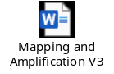 | Shows which pass and distinction descriptors need to be met through which assessment method, along with additional guidance of the evidence required.
 | This document will guide the apprentice through their Consultative Project, from identifying a suitable project, to carrying out the project activities and writing up the project report.
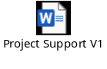 | This document provides support to apprentices in selecting an appropriate project, and in planning their project report.
 | To be completed by the apprentice to show the scope of their Consultative Project and how they intend to meet the learning outcomes. Must be submitted and signed off by the IEPA prior to work starting on the Consultative Project.
 | The apprentice may choose to use this document to present their project report. This document is not mandatory; the apprentice may choose to submit their report on their own Word or PDF document.
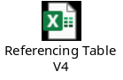 | This document must be used to map the Consultative Project, and additional evidence to each of the learning outcomes and is submitted at the same time as the Consultative Project.

Further guidance documents which you may find helpful, but are not specific to the HR Support standard are available to download from the Support Materials sections of EPA Pro. This includes:
- Policies and Procedures
- DSW Project Requirements
- Templates – witness testimony, observation record, context statement etc.
- Technical requirements for assessment and Zoom/WebEx/Teams user guides
- EPA Pro user guide
- Reasonable Adjustments, Special Considerations and Flexibilities policy
- Appeals policy

Appendix II – Toolkit Updates

Version 3 – August 2020
- Additional clarification added to project wordcount guidance

This change is applicable to all apprentices.

Version 4 – November 2020
- Covid flexibility document added

This change is applicable for apprentices who meet the requirements of the rules set out within the embedded dispensation document.

The below documents have been updated to reflect the changes above. The version numbers are the current ones for the documents embedded within version 4 of the toolkit.
- Covid Flexibilities for HR Support and HR Consultant Partner V1 document retired

Version 5 – November 2021
- Further guidance added regarding the project plan
- Further guidance added to the project plan template
- Resit guidance added
- Maximum wordcount for the project plan added
- Feedback to be received via an assessment record
- Amplification added to the learning outcomes document
- End date to covid flexibility amended in line with current guidance

This change will be applicable for apprentices who come through gateway on or after 1st January 2022. Apprentices who come through gateway before this date may also be assessed under this version if they will not be disadvantaged. This should be discussed with the end point assessor during the planning meeting.

The below documents have been updated to reflect the changes above. The version numbers are the current ones for the documents embedded within version 5 of the toolkit.
- Learning Outcomes and Amplification V2
- Project Proposal template V2
- Covid Flexibilities for HR Support and HR Consultant/Partner V2

Version 6 – October 2023
- Further guidance on appendices
- Further guidance on what is and what is not included in the wordcount for the Consultative Project.
- Infographic showing the end point assessment timeline added.
- Embedded documents amended in line with changes made to grading and amplification.
- Project Plan template layout improved with areas added to further support apprentices to plan their Projects.
- Clarification that the Consultative Project can be written in either first or third person.
- Grading approach changed in line with current guidance from Ofqual regarding L5 HR Consultant Partner, including distinction criteria written.

This change will be applicable for apprentices who come through gateway on or after 01/03/2024. Apprentices who come through gateway before this date may also be assessed under this version if they will not be disadvantaged. This should be discussed with the end point assessor during the planning meeting.

The below documents have been updated to reflect the changes above. The version numbers are the current ones for the documents embedded within version 6 of the toolkit.
- Mapping and Amplification V3
- Project Guidance V2
- Project Plan Template V3
- Referencing Table V3

V6.1 – November 2023
- Removed that the apprentice is limited to bringing 2 pages of notes into the Professional Discussion. Please refer to the Conditions for Live Assessments.

As this change has been designed to offer further support to apprentices and will have minimal impact, the change will take immediate effect.

V6.2 – February 2024
- The Consultative Project must be marked before the apprentice can attempt the Professional Discussion. The requirement to achieve a pass or a distinction in the Consultative Project before attempting the Professional Discussion has been removed.

This change will take immediate effect.

V7 – February 2025
- Further guidance around the timescales for retakes has been added to the resit and retake section.
- Should an apprentice submit a report outside of the given word count range, the assessment will still be carried out with anything over 3,300 words being disregarded
- Project Support document created to support apprentices to identify a suitable project and plan their project activity.
- Consultative Project Template created.
- Project Guidance document updated to provide further support to apprentices, training providers and employers.
- Signposting to DSW Project Requirements and Conditions for Live Assessments.
- Formula error fixed in the Referencing Table.

The rule regarding the word count of the project will take effect for all Consultative Projects assessed from 24/02/2025. Referencing Table V4 must be used from 01/07/2025. As the other above changes have been designed to offer further support to apprentices and will have minimal impact, they will take immediate effect.

The below documents have been updated to reflect the changes above. The version numbers are the current ones for the documents embedded within version 7 of the Toolkit.
- Project Support V1
- Project Report Template V1
- Project Guidance V3
- Referencing Table V4






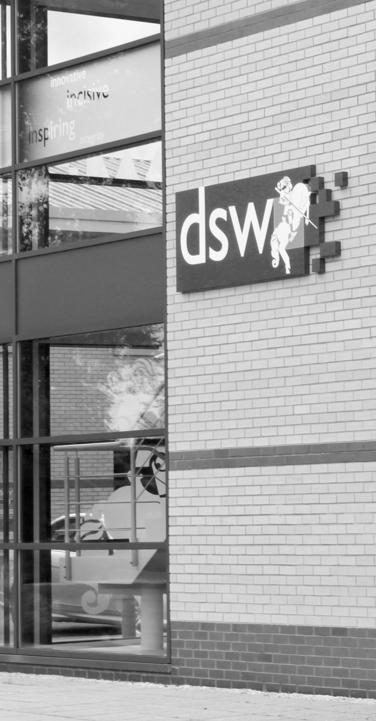
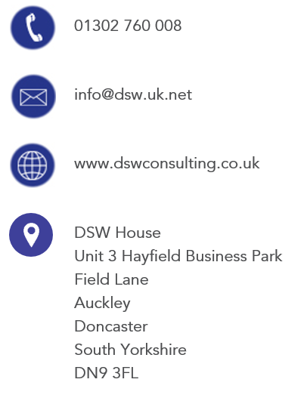
01302 760 008

EPA@dswlearning.co.uk

www.dswconsulting.co.uk

DSW House
Unit 3 Hayfield Business Park
Field Lane
Auckley
Doncaster
South Yorkshire
DN9 3FL

Doran Scott Williams & Co Ltd
©DSW 2025
All rights reserved. No part of this publication may be reproduced, stored in a retrieval system or transmitted in any form or by any means, electronic, mechanical, photocopying, recording or otherwise without the prior written permission of the publisher, DSW. This brochure may not be lent, resold, hired out or otherwise disposed of by trade in any binding or cover than that in which it is published, without prior consent from DSW. The law of copyright and its related rights in the UK applies and can be found in the copyrights sections in the Copyrights, Designs and Patents Act 1998 (as amended). Company Registered in England No 03803848

