




Business Administrator
Level 3
Toolkit




Contents
Introduction 3
Gateway 3
EPA Overview 3
EPA Timeline 4
Planning Meeting 4
Conditions for Assessment 5
Amplification 5
Knowledge Test 5
Project/Improvement Presentation with Q&A 6
Portfolio-based Interview 7
Grading Summary 9
Resits and Retakes 10
Appendix I – Supporting Documents 11
Appendix II – Updates to Toolkit 12

Introduction
DSW is your end-point assessment organisation for this apprenticeship. We have created this Toolkit to help the apprentice, training provider and the employer to understand what is needed to successfully complete end-point assessment (EPA) for this standard.

All approved end-point assessment organisations must carry out EPA in line with the assessment plan published by the Institute for Apprenticeships and Technical Education (IfATE). The assessment plan details the assessment methods used, the criteria to be assessed and the environment in which the assessments must take place.

The requirements and content of this Toolkit come directly from the Business Administrator Standard assessment plan. Additional clarification is provided by the external quality assurer (EQA) for this apprenticeship standard. You can download a copy of this from the IfATE website: https://www.instituteforapprenticeships.org/

Gateway
Apprentices must be on-programme for a minimum of 12 months before they come through gateway and enter the EPA phase of the apprenticeship. The apprentice, employer and training provider must agree that the apprentice is demonstrating competence against the standard's knowledge, skills, and behaviours (KSBs) and the associated grading descriptors.

Once an apprentice is ready for gateway, the training provider must submit the following to DSW’s epaPRO portal for approval:

- Gateway declaration
- Proof of level 2 English and maths
- Portfolio of evidence
- Completed Project Summary & Portfolio Referencing document.

More information on acceptable gateway evidence and the form to be submitted can be found on epaPRO under Support Materials > Gateway Documents.

If any of these requirements are not met, gateway will not be approved.

EPA Overview
The Business Administrator EPA consists of three assessment methods:

- Knowledge Test
- Project/Improvement Presentation
- Portfolio-based Interview

The assessment standard is made up of 50 pass and 49 distinction descriptors. Some of these descriptors are mapped to specific assessment methods, and some can be assessed in either the Project/Improvement Presentation or the Portfolio-based Interview. We refer to these as Core and Additional descriptors.

The Amplification document details which descriptors are assessed by each method and provides detailed information on what is required to fully meet each descriptor.

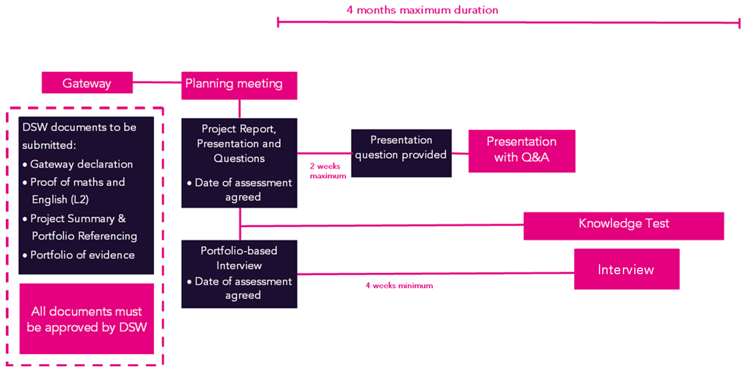
EPA Timeline

- The EPA period will begin once gateway has been approved
- All assessments must take place within the four-month EPA period. Apprentices will be processed as a fail if this timeframe is exceeded
- The Project/Improvement Presentation assessment must take place before the Portfolio-based Interview. The Knowledge Test can take place at any time.

Planning Meeting
Following gateway approval, DSW’s independent end-point assessor (IEPA) will contact the training provider to introduce themselves and arrange a planning meeting. Apprentices and employers are permitted to join the planning meeting if they request to do so.

This meeting will be used to agree the dates and times for the assessments, confirm which platform will be used and to share the project title and scope.

The assessments will be conducted virtually via the online video conferencing platform Microsoft Teams. Others, such as Webex or Zoom can be used if preferred.

Face-to-face assessments can be accommodated should the apprentice prefer. This should be discussed with the training provider and agreed with DSW. Additional costs will apply.

The IEPA will record the assessment dates in epaPRO once the planning meeting is complete.

Within two weeks of gateway approval the IEPA will review the project summary and provide a question to be addressed in the presentation.

Conditions for Assessment
All assessments must be taken under examination conditions. It is essential that apprentices familiarise themselves with the Conditions for Live Assessment, which can be found on epaPRO. The document sets out the mandatory requirements to ensure a secure and appropriate assessment environment, including apprentice ID requirements, panning of rooms and appropriate use of technology.

Failure to comply with the conditions for live assessment may result in delayed, cancelled, or failed assessments.

Amplification
The Amplification document outlines what the apprentice will be assessed against in each assessment method.

During the on-programme period, the apprentice will cover the knowledge, skills, and behaviours (KSBs) of the apprenticeship standard. The apprentice is not assessed against the KSBs; these have been used to create the pass and distinction criteria.

The apprentice’s competence will be assessed against the pass (P) and distinction (D) criteria during end-point assessment.

Amplifications are written to expand on the pass and distinction criteria. This simplifies and clarifies any complex, vague and/or ambiguous areas. Where examples have been listed, these are designed to provide guidance to the apprentice. The list is not exhaustive and the apprentice may use alternative examples that are relevant to their role.

Knowledge Test
The Knowledge Test is completed online using QuestionMark and must be taken under exam conditions. Once the apprentice has been approved for gateway, they will be provided with a guide and login details for QuestionMark.

The Knowledge Test will consist of 50 equally weighted multiple-choice questions. Each will have four possible answers, one of which will be correct.

The apprentice will have a maximum of 60 minutes to complete the test.

Preparing for Assessment
The Amplification document outlines the descriptors assessed by the Knowledge Test and the amplification section outlines how they will be assessed.

Once the apprentice has access to Question Mark, they will also have access to a mock test which will allow them to check the functionality of the system, and see the structure and type of questions used. Copies of the Mock Question Paper and the Mock Answer Sheet can be found here.

Results will be available within five working days.

Project/Improvement Presentation with Q&A

The Project
The apprentice will complete a project or improve a process. The project can be started at any point on the apprenticeship programme, cannot be completed before month nine but must be completed before end-point assessment is triggered.

The project or improvement should be work-based and account for 21–35 working hours. Examples of projects include creating a new process for managing and monitoring stock or designing guidance documents for a new piece of software.

The Project Summary & Portfolio Referencing document confirms which core descriptors will be assessed in the Project/Improvement Presentation with Q&A. Any additional descriptors for which evidence is not provided in the portfolio will also be assessed in the Project/Improvement Presentation with Q&A.

The apprentice is not obliged to provide evidence for distinction descriptors or target distinction criteria but must meet all core and additional pass and distinction criteria to achieve distinction.

Preparing for Assessment
When planning their project/improvement, apprentices should pay close attention to the wording of the descriptors and ensure that their evidence fully meets the specified criteria. Apprentices should consider the range and amount of evidence required. For example, many of the descriptors use the word ‘consistent’, indicating that evidence is needed over a period of time and/or across multiple situations. The amplification section of the Amplification document expands on this and will give the apprentice guidance on how much and what type of evidence should be provided.

The presentation is not submitted ahead of the live assessment.

The Presentation with Q&A
The Project Summary & Portfolio Referencing document contains a Project/Improvement Template that the apprentice must complete and submit at gateway.

The IEPA will review the project summary and provide a question that the apprentice must address in their presentation. The question will be provided within two weeks of gateway approval. The question provided will depend on the nature of the project/improvement being undertaken, and the coverage of the grading descriptors.

Sample presentation questions are provided in Appendix I – Supporting Documents.

The apprentice should prepare a 10–15 minute presentation that covers the question set by the IEPA, as well as the grading descriptors assigned to the project/improvement.

In addition to the grading descriptors, the project/improvement must allow the apprentice to evidence:

- Scoping
- Planning
- Managing
- Communicating with stakeholders
- Monitoring
- Reporting results

We therefore recommend that the presentation follows the above structure.

The presentation will be followed by a short break to allow the IEPA time to finalise their questions. After the break, there will then be a 10–15 minute Q&A to provide the apprentice with maximum opportunity to meet the grading descriptors. Sample questions can be found here.

The presentation is expected to be produced using presentation software such as Microsoft Office PowerPoint, Prezi, Keynote or Google Slides, demonstrating a minimum level of IT skill. The apprentice will deliver their presentation to the IEPA.

Results will be available within five working days. The IEPA will confirm on the Assessment Record which additional grading descriptors are being carried over to the Portfolio-based Interview. Additional grading descriptors can only be carried over if evidence has been provided for them in the portfolio.

Portfolio-based Interview

The Portfolio
The portfolio should be a showcase demonstrating the apprentice’s best work gathered during the on-programme stage of the apprenticeship. Examples cannot be collected until the apprentice has completed three months on programme.

The portfolio must include at least one piece of evidence for each pass descriptor. Each piece of evidence may map to more than one criterion. In addition to the pass criteria, the apprentice may also choose to map their evidence to the distinction criteria. A minimum of 8-12 pages is expected for consistency.

The Project Summary & Portfolio Referencing document details which core descriptors are assessed in the Portfolio-based Interview. The document should be used to map the evidence for all of the core descriptors, and any additional descriptors for which evidence is being provided in the portfolio. We recommend that at least 50% of the additional descriptors are evidenced in the portfolio.

The portfolio of evidence should not include reflective accounts or any methods of self-assessment. Any employer contributions should focus on direct observation of performance (for example, witness statements) rather than opinions. The evidence provided should be valid and attributable to the apprentice.

Please refer to DSW Portfolio Requirements for further information.

Preparing for Assessment
The portfolio will be reviewed by the IEPA ahead of the interview to help them prepare questions. As the portfolio is not assessed, feedback will not be provided on the portfolio evidence before the interview.

Interview
The Interview will take place between the apprentice and the IEPA and is designed to establish the apprentice’s competence against the grading criteria that are assigned to this assessment method.

The interview will last for a maximum of 45 minutes. If the interview exceeds this time limit, anything after 45 minutes will not be assessed.

The IEPA will ask a minimum of 10 questions. They may ask up to two follow-up prompts for each question to clarify their understanding, or probe for evidence for the distinction grading criteria. These questions will be based wherever possible on the examples given in the portfolio. Sample questions can be found here.

Results will be available within five working days.

Grading Summary

Knowledge Test
To achieve a pass, the apprentice must answer a minimum of 30 questions correctly.

To achieve a pass, the apprentice must answer a minimum of 40 questions correctly.

Project/Improvement Presentation
To achieve a pass, the apprentice must meet all seven core pass descriptors assigned to this assessment method. They must also meet any additional pass descriptors for which no evidence is being provided in the portfolio.

To achieve a distinction, the apprentice must meet all seven core pass descriptors and all eight core distinction descriptors assigned to this assessment method. They must also meet any additional distinction descriptors for which no evidence is being provided in the portfolio.

Note: The IEPA will grade any further additional pass and distinction descriptors demonstrated by the apprentice in the Project/Improvement Presentation, even if evidence is also being provided in the portfolio.

Portfolio-based Interview
To achieve a pass, the apprentice must meet all 13 core pass descriptors assigned to this assessment method. They must also meet any additional pass descriptors for which evidence is being provided in the portfolio.

To achieve a distinction, the apprentice must meet all 13 core pass descriptors and all 14 core distinction descriptors assigned to this assessment method. They must also meet any additional distinction descriptors for which evidence is being provided in the portfolio.

Note: Any additional pass or distinction descriptors which have been met in the Project/Improvement Presentation will not be assessed in the Portfolio-based Interview.

Overall Grading

In order to gain an overall grade of pass, apprentices must achieve a pass in all three assessment methods.

To achieve an overall grade of distinction, the apprentice must achieve a distinction in all three assessment methods.

Resits and Retakes
Apprentices who fail will be offered the opportunity to take a resit or a retake. A resit does not require further learning, whereas a retake does.

The apprentice’s employer will need to agree that a resit or retake is an appropriate course of action and should assist the apprentice in creating a supportive action plan to help them prepare for the resit or retake. The timescales and content of the further learning will be defined to support the apprentice ahead of the retake taking place.

An apprentice who fails an assessment method will be required to resit or retake the failed assessment method only.

Resits and retakes are not offered to apprentices wishing to move from a pass to a higher grade.

The timescales for a resit/retake are agreed between the employer and EPAO. A resit is typically taken within three months of the EPA outcome notification.

There is no grade capping for apprentices who fail an assessment method.

The EPA must be completed within a maximum of four months, otherwise the entire EPA must be taken again.

Appendix I – Supporting Documents
The documents in the table below have been developed specifically for the Business Administrator standard.

Document | Description
 | Use this document to map portfolio evidence and select which assessment method will be used for each additional pass/distinction descriptor. This document must be submitted at gateway.
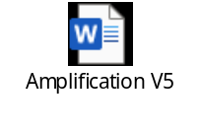 | This document details which descriptors are assessed by each method and outlines the types of evidence required for each.
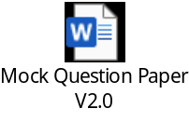 | A paper copy of the mock knowledge test is provided here.
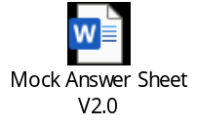 | Once the apprentice has completed the mock knowledge test, their answers can be checked using this answer sheet
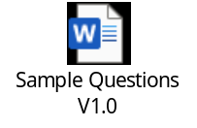 | Sample questions for the Project/Improvement Presentation and Portfolio-based Interview.

Further guidance documents which you may find helpful are available to download from the Support Materials sections of epaPRO. These include:

- Policies and Procedures
- Conditions for Live Assessment
- Templates – witness testimony, observation record, context statement etc.
- Technical requirements for assessment and Zoom/WebEx/Teams user guides
- epaPRO user guide
- DSW Portfolio Requirements
- Appeals, Reasonable Adjustments, Special Considerations and Flexibilities Policy

Appendix II – Updates to Toolkit

Version 2.0 – May 2022
- Project Referencing Table and Presentation Referencing Table removed.
- Project Scoping Template document removed and information moved to the Project Summary & Referencing document.
- ‘Mandatory’ and ‘Flexible’ descriptors replaced with ‘Core’ and ‘Additional’.
- Requirement to choose between 13–17 flexible pass descriptors for the Project/Improvement Presentation removed. The apprentice will choose the number of additional pass descriptors to evidence in the Portfolio-based Interview, and the remainder must be covered in the Project/Improvement Presentation.
- Clarified that the apprentice does not have to provide evidence for distinction descriptors, or target distinction descriptors.
- Explanation of rules of combination for apprentices who do want to aim for distinction added to the Amplification document.
- Amplification expanded for pass descriptors 38 around logistics to provide further guidance on the types of examples that could be used.
- Embedded documents moved to Appendix III.
- The mandated time frame for completion of assessment has been removed.

The following documents have been updated to reflect the changes above. The version numbers are current for the documents embedded within version 2 of the toolkit.
- Project Summary & Referencing V2.0
- Mapping Document V2.0

Version 2.1 – August 2023
- Amplification expanded for pass descriptors 37 and 38 to provide further guidance on what would be accepted.
- Clarification added as to when the project can commence.
- Personal Qualities moved from Core Grading Descriptors to Additional Grading Descriptors. This can now be assessed by either the Portfolio-based Interview OR the Project Improvement Presentation.
- EPA window now a maximum of four months
- Guidance added on the number of pages to be included in the portfolio

The following documents have been updated to reflect the changes above. The version numbers are current for the documents embedded within version 2.1 of the toolkit.
- Mapping Document V3.0
- Project Summary & Portfolio Referencing V2.1
- Mock Question Paper V2.0
- Mock Answer Sheet V2.0

V2.2 – November 2023
- Amplification for pass descriptors P2, P12, and P38 amended to provide further clarification.
- Formatting of the Mapping and Amplification document has been improved.

As these changes will have minimal impact and have been designed to further support apprentices and training providers, it will take immediate effect. The following documents have been updated to reflect the changes above. The version numbers are current for the documents embedded in version 2.2 of the Toolkit:
- Mapping document V4

V2.3 June 2024
- Amplification section added to explain the purpose of this document
- Mapping document renamed ‘Amplification document’.
- Amplification section updated and reformatted throughout.
- Rewrite of Amplification, including additional clarity added around acceptable evidence for P8, P12, P27, P37, P38, P39.
- Sample Questions moved to separate document.
- Further clarity added for retakes.

The above changes are applicable to apprentices with immediate effect.

The below document has been updated to reflect the changes above. The version numbers are

the current ones for the documents embedded within version 2.3 of the Toolkit:
- Amplification V5
- Sample Questions V1







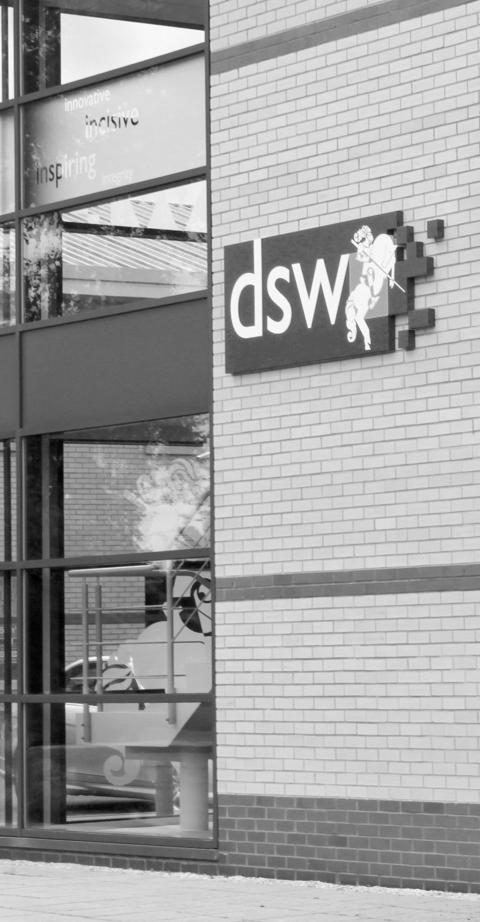
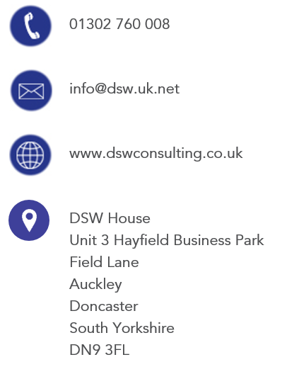
01302 760 008

EPA@dswlearning.co.uk

www.dswconsulting.co.uk

DSW House
Unit 3 Hayfield Business Park
Field Lane
Auckley
Doncaster
South Yorkshire
DN9 3FL

Doran Scott Williams & Co Ltd
©DSW 2024
All rights reserved. No part of this publication may be reproduced, stored in a retrieval system or transmitted in any form or by any means, electronic, mechanical, photocopying, recording or otherwise without the prior written permission of the publisher, DSW. This brochure may not be lent, resold, hired out or otherwise disposed of by trade in any binding or cover than that in which it is published, without prior consent from DSW. The law of copyright and its related rights in the UK applies and can be found in the copyrights sections in the Copyrights, Designs and Patents Act 1998 (as amended). Company Registered in England No 03803848

