




Senior People Professional
Level 7
Toolkit




Contents
Introduction 2
Key Steps 2
What is End Point Assessment? 2
End Point Assessment Overview 3
End Point Assessment Timeline 4
Assessment Method 1: Project Proposal, Presentation and Questioning 5
Overview 5
Project Proposal Report (with supporting evidence) 5
Presentation and Questioning 6
Grading the Project Proposal, Presentation and Questioning 7
Assessment Method 2: Professional Discussion Underpinned by a Portfolio of Evidence 7
Overview 7
Portfolio of Evidence 8
Professional Discussion 8
Grading the Professional Discussion Underpinned by a Portfolio of Evidence 8
Overall Grade 9
Resits/retakes 9
Reasonable Adjustments 9
Appendix I – Supporting documents 10
Appendix II – Sample Questions 11
Project Proposal, Presentation and Questions 11
Professional Discussion 11
Appendix III – Toolkit Updates 12
V1.1 – June 2024 12

Introduction
DSW is your End Point Assessment Organisation (EPAO) for this apprenticeship. We have created this Toolkit to help the apprentice, training provider and employer understand what is needed to successfully achieve End Point Assessment for this standard and complete the apprenticeship programme.

All EPAOs must carry out End Point Assessments in line with the assessment plan published by the Institute for Apprenticeships and Technical Education (IfATE). The assessment plan includes details of what is assessed, how it is assessed and how the grading criteria are applied. All End Point Assessments must be carried out under controlled assessment conditions.

The requirements and content of this toolkit come directly from the Senior People Professional assessment plan with additional clarification provided by Ofqual, the external quality assurer for this apprenticeship. Published assessment plans are available on the IfATE website: https://www.instituteforapprenticeships.org

Key Steps

Gateway-ready
- Employer is satisfied that the apprentice has achieved occupational competence and is consistently demonstrating the knowledge, skills and behaviours set out in the standard
- Employer and training provider confirm that apprentice is gateway-ready
- Gateway documents submitted to DSW’s EPA Pro portal for approval, including proof of English and Maths Level 2 achievement (or valid exemption), plus:
- a summary of the title and scope of the project proposal
- a portfolio of evidence to support the professional discussion with completed referencing table

The gateway will be approved within 5 working days of the documents begin submitted

EPA period – typical duration 4 months
- DSW will administer the two assessments that together form the End Point Assessment:
- Project proposal, presentation and questioning
- Professional discussion underpinned by a portfolio of evidence.
- Results will be issued via email to the training provider within five working days of the completion of each assessment

What is End Point Assessment?

End Point Assessment (EPA) is the name given to a series of assessments an apprentice must undertake to prove their ability to do the job for which they have been training. The assessments take place at the end of an apprenticeship, following a period of training and development often referred to as the ‘on-programme’ period. The assessments must be carried out by an approved End Point Assessment Organisation (EPAO) and account for 100% of the assessment of the apprenticeship. DSW has been selected by the apprentice’s employer as the EPAO for this apprenticeship.

Upon successful completion of the on-programme phase of the apprenticeship, the apprentice will move into the ‘gateway’ period. Once the gateway criteria have been met, DSW’s Independent End Point Assessor (IEPA) will contact the training provider to schedule in dates for each assessment. It should typically take 4 months to complete the entire EPA.

During the EPA phase, the apprentice must complete the required assessments with support from their employer and training provider. All assessments must be passed for the apprentice to be deemed competent and achieve their EPA overall.

On successful completion of all EPA activities, DSW will request the apprentice’s certificate from the Education and Skills Funding Agency. This will be sent to the employer’s address marked for the attention of the apprentice. It can take up to eight weeks for certificates to arrive.

End Point Assessment Overview

The Senior People Professional EPA consists of two assessment methods:

- Project proposal, presentation and questioning
- Professional discussion underpinned by a portfolio of evidence

There are 20 or 21 pass and 8 or 9 distinction criteria, depending on the pathway taken, that the apprentice must meet across the two assessment methods.

The pathways for this standard are:
- Human Resources
- Learning and Development
- Organisational Development

The Mapping and Amplification document, which can be found in appendix I, lists the grading criteria and gives some guidance as to how the apprentice may demonstrate competence against each one.

End Point Assessment Timeline
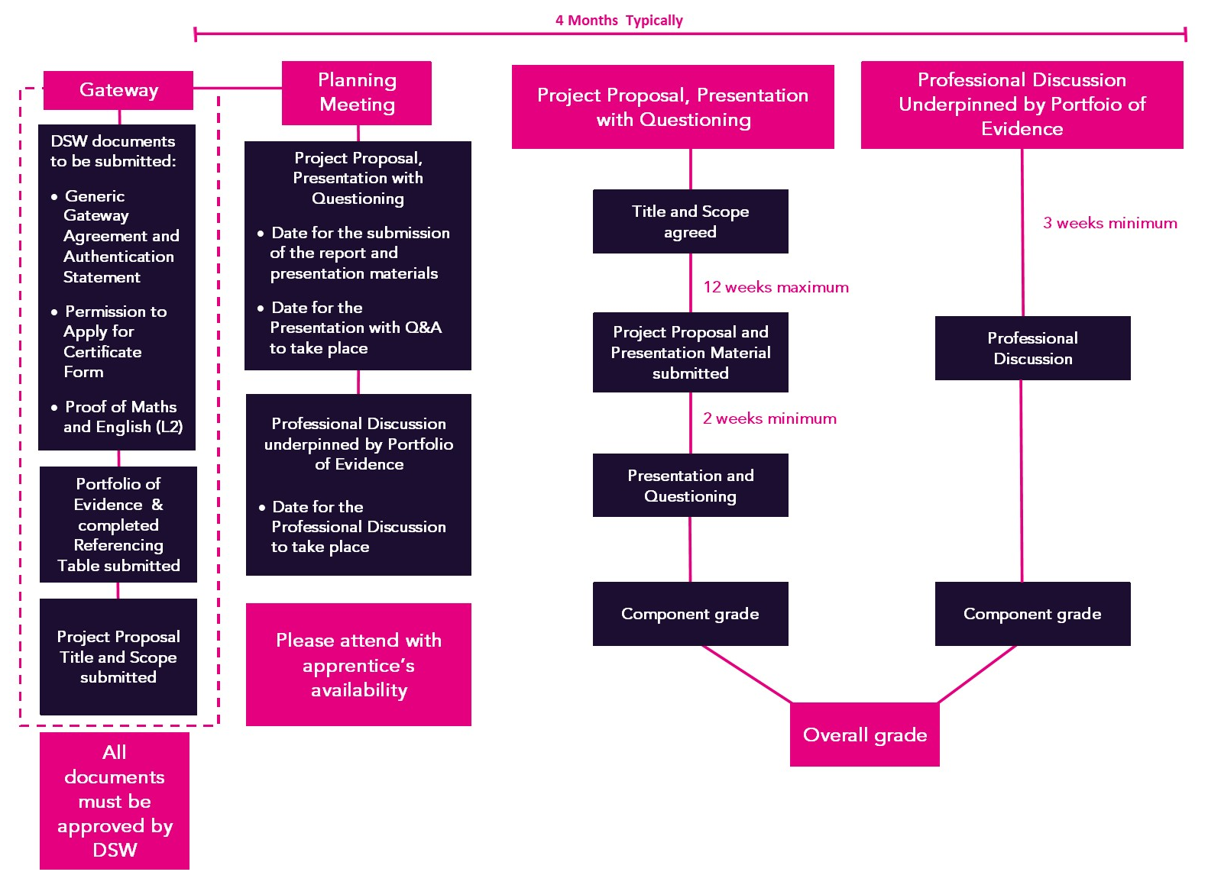

If the project proposal report, presentation and referencing table are not submitted within 12 weeks of the summary being approved this assessment method will be graded as a fail.

The end point assessment period will last for typically 4 months, but there is no mandated maximum period. The Professional Discussion may take place at any point during the end point assessment period and is not impacted by the Project Proposal, Presentation and Questioning assessment method.

Assessment Method 1: Project Proposal, Presentation and Questioning

Overview
The project proposal is a relevant and defined piece of work that has real business benefit. It should be designed to ensure that the apprentice’s work meets the needs of the business, is relevant to their role and allows the grading criteria to be assessed.

The title and scope of the project proposal should be decided by the apprentice and the employer to ensure that it meets a genuine business need. The proposal could be based on areas such as:

- The need to review and agree a change plan to improve a people solution within the workplace.
- The continuous improvement review of a current process, service or product to ensure it is still fit for purpose and meets the current needs of the business.
- The planning and design of a project that has strategic relevance and the potential to add value to the organisation.

A brief summary of the project proposal should be submitted at gateway using the template provided in appendix I. This should be no more than 500 words and should outline the title and scope of the proposal. It should be signed by the employer to confirm that it has real business application.

Alongside the summary, the apprentice should briefly explain how they will evidence each of the grading criteria.

The IEPA will review the summary and confirm that it allows the apprentice the opportunity to evidence all of the grading criteria. Once the IEPA has approved the project proposal the apprentice will have 12 weeks to carry out work on the proposal and submit a report and presentation material, along with the completed referencing table. If the report is submitted after this date, this assessment will be graded as a fail.

It is of vital importance that the apprentice does not commence work on their project proposal until after their summary has been formally approved by DSW at gateway. Starting the work ahead of gateway will invalidate the assessment.

The proposal does not need to be fully implemented during the EPA period but must be a comprehensive project proposal that will enable full implementation at an appropriate time for the organisation.

Project Proposal Report (with supporting evidence)
The project proposal report must include:
- An executive summary
- An introduction
- The scope of the proposed project (including key performance indicators)
- Objectives
- How the proposed project outcomes would be achieved
- Comment on the validity of the methods of analysis, data interpretation and data presentation used
- Proposed implementation plan including communications and stakeholder plans
- Advise whether an alternative approach might be considered
- Recommendations and conclusions
The apprentice must complete their project proposal unaided, and both the employer and the apprentice must verify this by signing the declarations on the Project Proposal Referencing Table. Where the apprentice works with others, for example when consulting with stakeholders, they should use their presentation to evidence the knowledge and skills they utilised and to explain the contribution made by others.

The report must be between 6,300 and 7,700 words. Any reports with a word count below 6,300 will not be accepted and will be marked as a fail. Reports with a word count above 7,700 words will be accepted and marked based on the first 7,700 words. Anything in excess of this will not be assessed.

The report should be referenced, where appropriate, to the original source. The apprentice may use a referencing system of their choice, provided it is clear and easily understood, with any reference to others’ work clearly attributed.

Supplementary evidence may be included in the report, such as:
- Diagrams
- Tables, charts and graphs
- Screenshots
- Photographs
- Extracts from policies or process notes
- Extracts of relevant legislation
- Copies or extracts of presentations
- Copies or extracts of industry journals or publications

Tables, graphs and figures will be included in the wordcount. Any evidence presented as an appendices or annex will not be included in the wordcount

The apprentice may choose to embed supporting evidence within the main body of their report, or as appendices. Whichever method the apprentice chooses, it is their responsibility to ensure that all evidence is clearly mapped to the assessment criteria using the Proposal Referencing Table contained within this toolkit. Any supporting evidence in the appendices must be referred to within the main body of the report.

The Project Proposal Referencing Table is a mandatory document which must be completed by all apprentices and submitted alongside the report and presentation materials. The referencing table lists all the assessment criteria and includes fields for the apprentice to indicate the title and location of the evidence which corresponds to each criterion. An example can be found on the instructions tab of the referencing table.

It is the apprentice’s responsibility to complete the referencing table and map their own evidence. Each individual assessment criterion may be covered by more than one piece of evidence.

Presentation and Questioning
The presentation will be delivered to the IEPA and is designed to expand on the project proposal. It should provide evidence to strengthen the coverage of the grading criteria from the project proposal report and should include:

- The intended outcomes of the project proposal.
- How the apprentice has undertaken the planning for the project proposal.
- The rationale for the activities.
- Outcomes of the board or senior leader sign-off.
- Further recommendations for consideration.

The presentation slides must be submitted at the same time as the report. If the slides have notes attached these can also be submitted. The slides must not be amended after they have been submitted as this may result in the assessment being terminated.

Following submission of the proposal and presentation materials the IEPA will have 2 weeks to assess the report and prepare questions. Feedback will not be provided prior to the presentation and questioning.

The presentation should last for a maximum of 26 minutes and will take place on the agreed date and will be followed by a question-and-answer session. The full assessment will last a maximum of 60 minutes with an additional 6 minutes available at the IEPA’s discretion to allow the apprentice to complete their last answer. In order to ensure that sufficient time is available for the question-and-answer session, the presentation will be stopped after a maximum of 26 minutes. The IEPA will give the apprentice a 2-minute warning before stopping the presentation.

Following the presentation, there will be a break of up to 10 minutes to allow the IEPA to review the questions they have planned for the question-and-answer portion of the assessment. The IEPA may choose to end the call for the break, or to stay on the call and mute their microphone. The IEPA will inform the apprentice of the break and whether they should stay on the call or not.

The IEPA will ask a minimum of 8 questions. These questions will be taken from a bank to ensure consistency however the IEPA may contextualise these to align them to the apprentice’s project proposal. They are designed to confirm the IEPA’s understanding of the presentation and how it demonstrates the relevant grading criteria.

For each core question, the IEPA may ask two follow-up questions. Follow-up questions will typically be used where the IEPA does not yet feel a criterion has been fully met, or where they are exploring further to see if it has been exceeded. Sample questions have been provided in Appendix II.

The apprentice will have access to audio-visual presentation equipment, flip chart and writing and drawing materials and a computer as required.

Grading the Project Proposal, Presentation and Questioning
The project proposal report will be graded holistically alongside the presentation and questioning.

In order to pass the assessment, the apprentice must fully meet all the pass criteria allocated to the assessment method through a combination of the report, presentation and questioning.

To achieve a distinction, in addition to meeting all the pass criteria, the apprentice must fully meet all the distinction criteria allocated to the assessment method.

Assessment Method 2: Professional Discussion Underpinned by a Portfolio of Evidence

Overview
The professional discussion is a 2-way discussion between the apprentice and the IEPA designed to allow the apprentice to demonstrate the application of skills and behaviours as well as their knowledge and understanding. It is underpinned by a portfolio of work-based evidence.

Portfolio of Evidence
The portfolio should be compiled from the best work gathered on programme. It must contain at least one piece of evidence mapped clearly to each grading criteria, assigned to this assessment method. Although each piece of evidence may map to more than one criteria, this will typically result in 15 pieces of evidence.
Evidence may include:
- workplace documentation/records, for example workplace policies/procedures/processes, records
- witness statements
- annotated photographs
- video clips (maximum total duration 15 minutes); the apprentice must be in view and
- identifiable
- people plans and strategies, communications
This is not a definitive list and other evidence sources are allowable. Appendix I provides further guidance on what type of evidence can be included in the portfolio and a steer on how to ensure that the evidence is sufficient, authentic, relevant and current. Reflective accounts or any methods of self-assessment are not allowed. Any employer contributions should focus on direct observation of performance (for example, witness statements) rather than opinions
The Portfolio Referencing Table, which can be found in appendix I, provides details the grading criteria. Please also refer to DSW Portfolio Requirements.

The portfolio must be submitted at Gateway along with the completed referencing table which should be used to map the evidence in the portfolio to the grading criteria. It is the apprentice’s responsibility to complete the referencing table and map their own evidence.

The referencing table must be signed by the employer and the ATP confirming that the evidence provided is valid and attributable to the apprentice.
The portfolio of evidence is not directly assessed but is reviewed by the IEPA and underpins the professional discussion.

Professional Discussion
The professional discussion will take place a minimum of 3 weeks after Gateway on a date agreed in the planning meeting and is a two-way discussion between the apprentice and IEPA lasting 120 minutes (plus 10% at the IEPAs discretion to allow the apprentice to complete their last answer).

During the discussion, the IEPA will use a minimum of 10 opening discussion prompts to open up discussions. To ensure consistency, DSW holds a bank of core questions, however the IEPA may contextualise these to align them to the apprentice’s portfolio or generate their own questions. Sample questions have been provided in Appendix II.

Grading the Professional Discussion Underpinned by a Portfolio of Evidence
To pass this assessment method, the apprentice must meet all the pass criteria allocated to the assessment method.

To achieve a distinction, in addition to meeting all the pass criteria, the apprentice must meet all the distinction criteria allocated to the assessment method.

Overall Grade

There are three grades available – fail, pass and distinction.

To achieve a pass, the apprentice must pass both assessment methods.

To achieve a distinction, the apprentice must achieve a distinction in both assessment methods.

Resits/retakes

Apprentices who fail one or more assessment methods will be offered the opportunity to take a resit or a retake of the failed assessment within the EPA period. A resit does not require further learning, whereas a retake does.

The apprentice’s employer will need to agree that a resit or retake is an appropriate course of action and should assist the apprentice to create a supportive action plan to help them prepare for the resit or retake.
In the case of a resit or a retake the IEPA will ask a different set of questions.
If the apprentice fails the project proposal assessment method, the apprentice will be given 3 weeks to amend the project proposal and presentation in line with feedback from the IEPA. The independent assessor will have 2 weeks to review the project proposal and presentation and the apprentice will have 5 days’ notice of the presentation date.

There is no grading cap applied to this standard. Resits and retakes are not offered to apprentices wishing to move from a pass to distinction.
The timescales for a re-sit/re-take are agreed between the employer and EPAO. A re-sit is typically taken within 2 months of the EPA outcome notification. The timescale for a re-take is dependent on how much re-training is required, however all assessment methods must be taken within 3 months of the EPA outcome notification.

Reasonable Adjustments

DSW are committed to providing apprentices who have additional support needs with a range of adjustments to reduce any disadvantage that a disability or a physical or mental health condition may cause during the End Point Assessment.

The Reasonable Adjustments and Special Considerations Policy and Form are available to download from here: https://www.dswconsulting.co.uk/our-policies, and are also available to download from EPA Pro

Appendix I – Supporting documents
The documents in this table have been developed specifically for the Level 7 Senior People Professional standard.

Document | Description
 | Shows which pass and distinction criteria need to be met through which assessment method, along with additional guidance of the evidence required.
 | This document is submitted at gateway. The apprentice will give a brief explanation of the nature of the project proposal and the business need it is addressing. This will be signed-off by the IEPA.
 | To be completed by the apprentice to map their portfolio evidence to the grading criteria. This must be submitted at gateway with the portfolio.
 | This document must be used to map the project proposal, and additional evidence to each of the grading criteria and is submitted at the same time as the project proposal.

Further guidance documents which you may find helpful, but are not specific to the HR Support standard are available to download from the Support Materials sections of EPA Pro. This includes:
- Policies and Procedures
- DSW Project Requirements
- Templates – witness testimony, observation record, context statement etc.
- Technical requirements for assessment and Zoom/WebEx/Teams user guides
- EPA Pro user guide
- Reasonable Adjustments, Special Considerations and Flexibilities policy
- Appeals policy

Appendix II – Sample Questions

Project Proposal, Presentation and Questions
In your project proposal you gained support from the head of sales and the head of product. Can you justify the approach that you took to do this?

How did you ensure that the decisions you made whilst working on your project proposal were based on evidence and lead to sustainable recommendations?

Professional Discussion
Below are examples of discussion points that the IEPA may have prepared to ask during the Professional Discussion. The assessment should be a free-flowing discussion and the IEPA may prompt to explore other grading criteria. Examples of the type of prompt that may be asked are given under each discussion point.

Discussion Point:

In your portfolio you've explained reviewed and updated your organisations appraisal process. Can you explain how you approached this, including how you made use of technology?

Possible prompts:
- How does the new policy link in with the culture of your organisation?
- How does the new policy provide value for the organisation and for the people within the organisation?

Discussion Point:

When you developed the induction programme for new employees how did you use new or updated principles for adult learning or motivation?

Possible prompts:
- How did you make use of coaching and mentoring on this programme?

Appendix III – Toolkit Updates

V1.1 – June 2024
- Appendix I – Portfolio Requirements removed as this has been replaced by DSW Portfolio Requirements.
- All embedded documents have been moved to Appendix I – Supporting documents.
- Correction made to the timings of the presentation and questioning – this is a maximum of 60 minutes.

The above changes will take immediate effect.







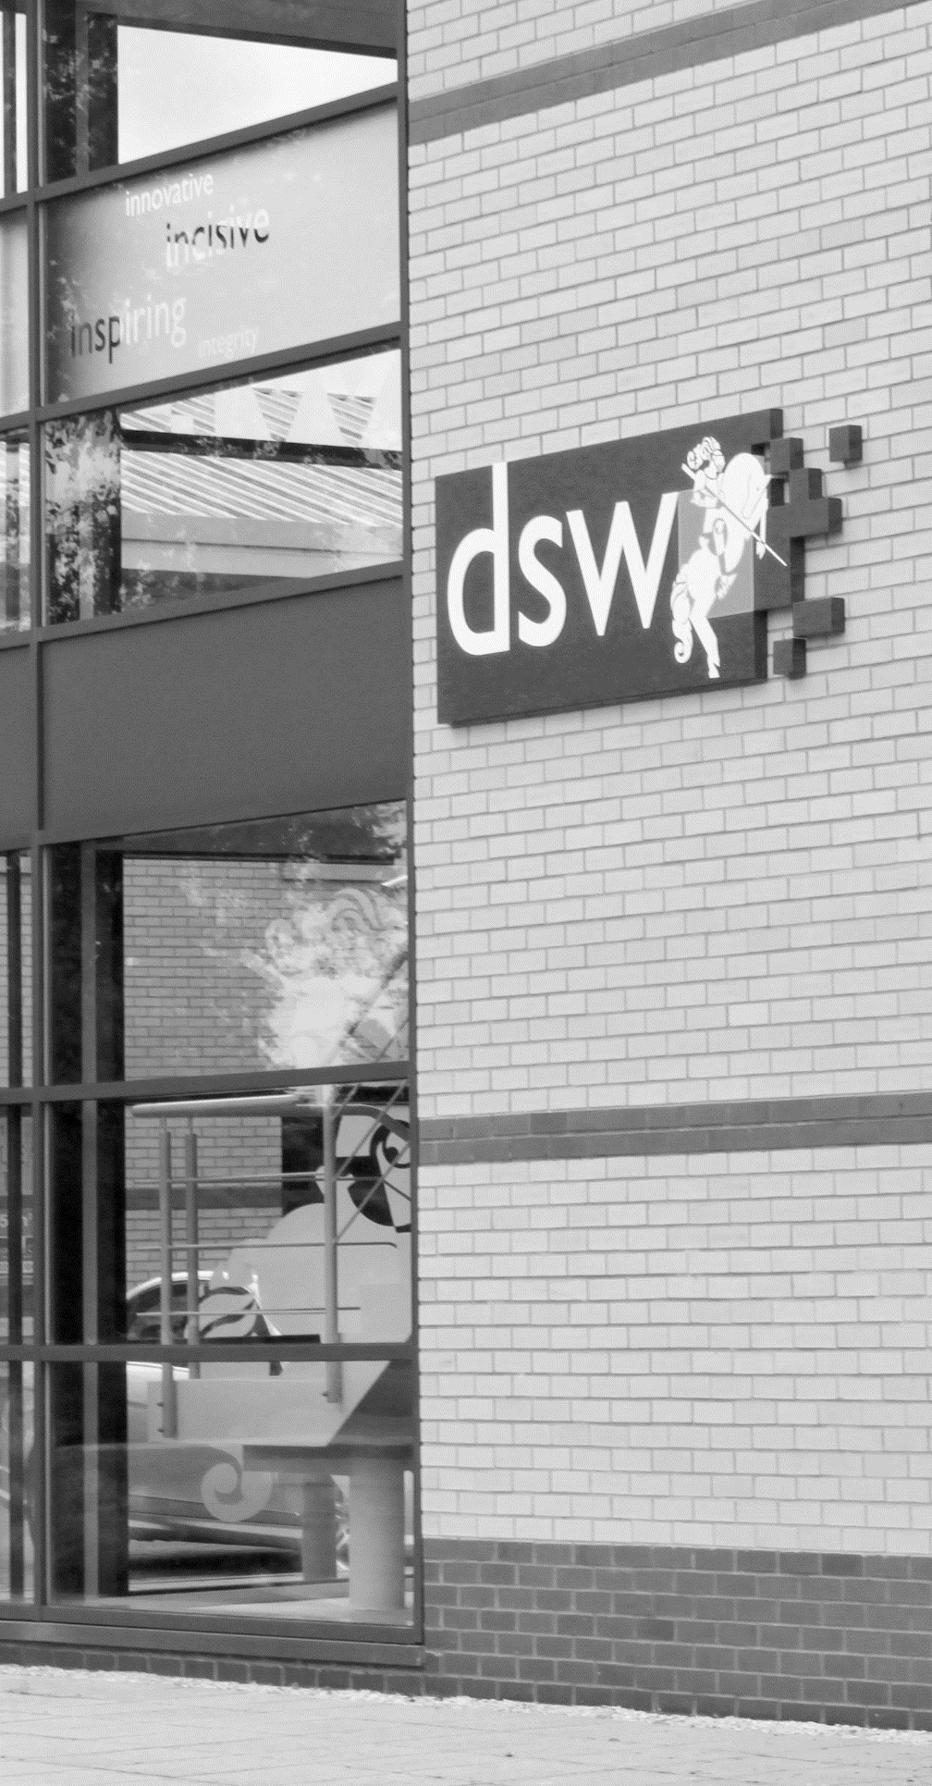
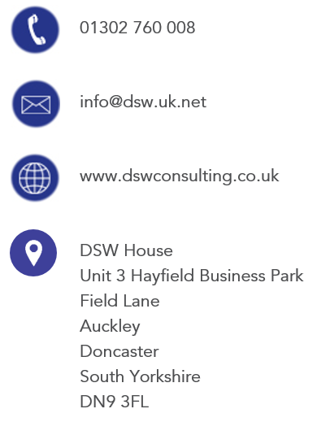
01302 760 008

EPA@dswlearning.co.uk

www.dswconsulting.co.uk

DSW House
Unit 3 Hayfield Business Park
Field Lane
Auckley
Doncaster
South Yorkshire
DN9 3FL

Doran Scott Williams & Co Ltd
©DSW 2024
All rights reserved. No part of this publication may be reproduced, stored in a retrieval system or transmitted in any form or by any means, electronic, mechanical, photocopying, recording or otherwise without the prior written permission of the publisher, DSW. This brochure may not be lent, resold, hired out or otherwise disposed of by trade in any binding or cover than that in which it is published, without prior consent from DSW. The law of copyright and its related rights in the UK applies and can be found in the copyrights sections in the Copyrights, Designs and Patents Act 1998 (as amended). Company Registered in England No 03803848

