




Team Leader or Supervisor
Level 3
Toolkit




Contents
Introduction 2
Gateway 2
End Point Assessment Overview 2
EPA Timeline 3
Presentation with Questions and Answers 4
Professional Discussion underpinned by Portfolio of Evidence 6
Grading 8
Resits and Retakes 9
Appendix I – Sample Assessments 10
Appendix II – Supporting Documents 11
Appendix III – Toolkit Amendments 12

Introduction
DSW is your End Point Assessment Organisation (EPAO) for this apprenticeship, and we have created this Toolkit to help the apprentice, Apprenticeship Training Provider (ATP) and employer to understand what is needed to successfully achieve End Point Assessment for this standard and complete the apprenticeship programme.

All EPAOs must carry out End Point Assessments in line with the assessment plan published by the Institute for Apprenticeships and Technical Education (IfATE). The Assessment Plan includes details such as the form the assessments can take, the environment in which they must be undertaken, what is to be assessed and the grading criteria. End Point Assessment must be carried out under examination conditions.

The requirements and content of this Toolkit come directly from the Team Leader or Supervisor assessment plan with additional clarification provided the External Quality Assurer (EQA) for this apprenticeship standard. Published assessment plans are available on the IfATE website: https://www.instituteforapprenticeships.org/

Typical job titles of those undertaking this apprenticeship include Supervisor, Team Leader, Project Officer, Shift Supervisor, Foreperson, and Shift Manager.

Gateway
Apprentices must be on-programme for a minimum of 12 months before they come through gateway and enter the End Point Assessment (EPA) phase of the apprenticeship. The apprentice, employer and training provider must agree that the apprentice is demonstrating competence against the knowledge, skills, and behaviours of the standard.

Once an apprentice is ‘gateway-ready’, the training provider must submit the following to DSW’s EPA Pro portal for approval:
- Generic Gateway Agreement and Authentication Statement
- Permission to Apply for Certificate Form
- Proof of Level 2 English and maths
- Portfolio of Evidence with completed Referencing Table – Please see page 7 for more details.

Any forms requiring a signature must be completed using either a wet or digital signature, otherwise they will be rejected.

More information on acceptable gateway evidence and the forms to be submitted can be found on EPA Pro under Support Materials > Gateway Documents.

Within two working days of gateway approval, DSW’s Independent End Point Assessor (IEPA) will contact the training provider to arrange a planning meeting. The IEPA will contact the person listed on EPA Pro as the apprentice’s on-programme assessor. The key dates associated with the end point assessment will be agreed during the meeting and confirmed via email to the ATP.

End Point Assessment Overview
The Team Leader or Supervisor EPA consists of two assessment methods:
- Presentation with Questions and Answers
- Professional Discussion underpinned by Portfolio of Evidence

The standard is made up of 50 knowledge, skills and behaviours which have been grouped into grading descriptors to enable specific elements to be tested by each assessment method.

There are 22 pass descriptors and 12 distinction descriptors.

There are 13 pass descriptors and 7 distinction descriptors assigned to the Presentation with Questions and Answers.

There are 9 pass descriptors and 5 distinction descriptors assigned to the Professional Discussion underpinned by Portfolio of Evidence.

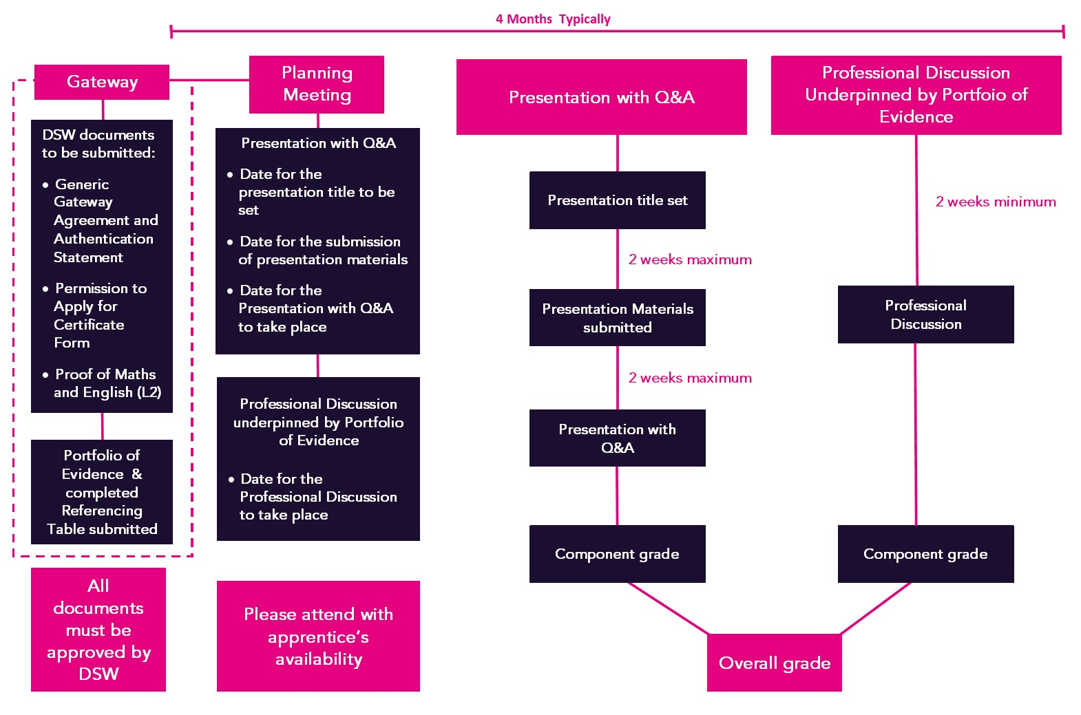
EPA Timeline

- The EPA period is typically 4 months. There is no maximum mandated period but please take note of the strict timelines applied to the Presentation with Questions and Answers assessment method.
- If the presentation materials are not submitted within 2 weeks of the title being set, the Presentation with Questions and Answers will be graded as a fail.
- If the Presentation with Questions and Answers does not take place within 4 weeks of the presentation title being set, the assessment method will be graded as a fail.
- If an apprentice fails a component, the maximum overall grade they can achieve is a pass.
- The Presentation with Questions and Answers will last for a maximum of 55 minutes.
- The Professional Discussion will last for a maximum of 60 minutes. The IEPA may apply an additional 6 minutes to the discussion to allow the apprentice to complete their final answer.
- The Presentation with Questions and Answers and Professional Discussion may take place on the same day, or on different days.

Presentation with Questions and Answers

Presentation
The Independent End Point Assessor (IEPA) will set the apprentice a Presentation Title which will be based on one of the following topics:
- Reviewing ways to reduce cost and increase efficiency in a business environment.
- Implementing a performance management process within a team or business unit.
- Supporting their team through a period of change within their organisation.
- Managing a difficult situation with their team.

The Presentation Title will be made available on the pre-agreed Issue Date.

The Issue Date is agreed during the Planning Meeting and is when the assessor will make the title available. The beginning of the 2 weeks in which the presentation materials are to be developed and submitted is the day after the Issue Date.

The apprentice will have 2 weeks to prepare and submit their presentation materials, along with any notes they wish to submit. Should the Presentation Materials are not received by 23:59 on the agreed submission date (also confirmed during the Planning Meeting). In that case, the Presentation with Questions and Answers component will be graded as a fail.

Example:
- Issue date - Monday 01st
- The start of the 2-week material development period - Tuesday 02nd
- Submission of materials - 23:59 on the Tuesday 16th.

If the apprentice, employer, or training provider feels the apprentice won’t be able to demonstrate all the required grading descriptors with the title they have been set, they will be able to reject it. The training provider must inform the IEPA that they wish to reject the title prior to the date set for the presentation materials to be submitted. If the IEPA does not receive the presentation materials or notice of the rejection within the timescales, the Presentation with Questions and Answers assessment method will be graded as a fail.

In the event of the presentation title being rejected, the IEPA will set an alternative presentation title which cannot be rejected. The IEPA will also inform the training provider of the date the presentation materials must be submitted, ensuring the Presentation with Questions and Answers takes place in line with the timescales for this assessment method.

The apprentice should include the following elements within their presentation:
- A brief summary of the apprentice’s role as a team leader, explaining what they do and how this is relevant to their role and organisation It is recommended that this section last for no more than 3 minutes.
- An explanation of the activities undertaken – this may be a defined piece of work that the apprentice has completed, or various activities that they were involved in throughout the on-programme period in relation to the presentation title
- A conclusion:
- What was achieved
- What lessons can be learned
- How they have demonstrated the pass and distinction descriptors of the standard

The apprentice should also ensure they have demonstrated all the pass grading descriptors assigned to the Presentation with Questions and Answers within their presentation. Apprentices aiming for an overall grade of distinction should also demonstrate the distinction grading descriptors. Apprentices may use whichever medium they choose for their presentation, but the materials must be submitted electronically on EPA Pro.
Tip – The presentation should typically last for 20 minutes. Before submitting their presentation materials, the apprentice may wish to practice their presentation to ensure it lasts for 20 minutes.

Once the presentation materials have been submitted, they must not be amended. If the apprentice delivers an amended version of their presentation, the IEPA may terminate the assessment and a fail grade may be issued for this assessment method.

Delivering the presentation
The apprentice will deliver their presentation to the IEPA via a video conferencing platform such as Zoom, WebEx or Teams. Whilst presenting, the apprentice should ensure the IEPA is able to view their materials, such as by sharing their screen.
Tip – If the apprentice has a preferred platform, please let the IEPA know during the planning meeting. It is also recommended that the apprentice tests the software and ensures they can share their screen prior to the live assessment.
The apprentice may request a time check during their presentation, such as to be informed when they have used 10 minutes. The IEPA will endeavour to do this at a suitable time, such as in between slides or sections.

Following the presentation there will be a break of up to 10 minutes to allow the IEPA to review the questions they have planned for the question and answer portion of the assessment. The IEPA may choose to end the call for the break, or to stay on the call and mute their microphone. The IEPA will inform the apprentice of the break and whether they should stay on the call or not.

Questions and Answers (Q&A)
Following the break, if the IEPA left the call, or if they believe that the assessment conditions may have been compromised, the apprentice will be required to pan their camera around the room again.

The questions and answer portion of the assessment will last for typically 30 minutes. The apprentice’s responses must relate to the examples they have given during their presentation.

The apprentice will be asked a minimum of 5 questions, one from each of the following areas:
- Team building and development
- Communication
- Organisational culture and strategy
- Problem solving
- Data analysis

The IEPA may also ask follow-up questions to clarify their understanding, or probe for evidence for the distinction grading descriptors.
Tip – Apprentices may find it helpful to use STAR to frame their responses:
Situation: Describe the situation and when it took place
Task: Explain the task and the goal
Action: The action(s) they took to achieve the goal
Result: Explain the result of their actions
The examples the apprentice gives must relate to the examples provided within the presentation.

Grading
To achieve a pass in the Presentation with Question and Answers, the apprentice must meet all 13 pass descriptors which are mapped to this assessment method.

To achieve a distinction in the Presentation with Question and Answers, the apprentice must meet all 13 pass descriptors and all 7 of the distinction descriptors which are mapped to this assessment method.

Feedback will be available via an assessment record once the result for this assessment method has been released.

Professional Discussion underpinned by Portfolio of Evidence

Portfolio of Evidence
The portfolio should be a showcase demonstrating the apprentice’s best work gathered during the on-programme stage of the apprenticeship. Evidence must be mapped to the descriptors using the Portfolio Referencing Table. The portfolio evidence is not assessed but should give the IEPA an insight into the apprentice’s role and the work they have carried out during the apprenticeship.

The portfolio must contain at least one piece of evidence mapped clearly to each pass descriptor assigned to this assessment method. Although each piece of evidence may map to more than one pass descriptor, this will typically result in 20 pieces of evidence to cover all descriptors listed. In addition to the pass descriptors, apprentices may also choose to map evidence to the distinction descriptors.

The portfolio and referencing table will be submitted at gateway to DSW. The IEPA will review the evidence and use it to help them prepare discussion points for the Professional Discussion. As the portfolio is not assessed, feedback will not be provided on the portfolio evidence prior to the discussion.

A date and time for the Professional Discussion to take place will be agreed at the planning meeting. Apprentices should be given at least 2 weeks’ notice to prepare for the discussion.

Professional Discussion
The Professional Discussion is a structured dialogue between the apprentice and the IEPA, designed to establish the apprentice’s competence against the grading descriptors that are assigned to the Professional Discussion.

The Portfolio of Evidence can be referred to by the apprentice and the IEPA during the Professional Discussion. The apprentice is permitted to bring notes and a copy of their portfolio into the discussion for reference. It is strongly recommended that apprentices review the content of the portfolio prior to the discussion.

The discussion will last for 60 minutes (+6 minutes at the discretion of the IEPA to allow the apprentice to finish their final answer). If the discussion exceeds this time limit, anything after 66 minutes will not be assessed.

The IEPA will prepare a minimum of 6 discussion points based on the evidence seen in the portfolio. These will be used to guide the discussion to ensure that all necessary descriptors are covered. Each discussion point will be used to open a free-flowing discussion and the IEPA may prompt for further information as appropriate. The apprentice may use examples from any part of the apprenticeship. Discussion points will focus on the examples of work provided in the apprentice’s Portfolio of Evidence.
Tip – Apprentices may find it helpful to use STAR to frame their responses:
Situation: Describe the situation and when it took place
Task: Explain the task and the goal
Action: The action(s) they took to achieve the goal
Result: Explain the result of their actions

To achieve a pass in the Professional Discussion underpinned by Portfolio of Evidence, the apprentice must meet all 9 pass descriptors which are mapped to this assessment method.

To achieve a distinction in the Professional Discussion underpinned by Portfolio of Evidence, the apprentice must meet all 9 pass descriptors and all 5 distinction descriptors which are mapped to this assessment method.

Feedback will be available via an assessment record once the result for this assessment method has been released. Once both assessment methods have been completed, the overall grading and feedback will also be made available.

Grading
There are two graded assessment methods:
- Presentation with Questions and Answers
- Professional Discussion underpinned by Portfolio of Evidence

Apprentices must achieve a minimum of a pass in both assessment methods to achieve an overall pass, and a distinction in both assessment methods to achieve an overall distinction.

Each assessment method is graded either a fail, pass or distinction as shown in the table below:

Assessment Method | Fail | Pass | Distinction
Presentation with Questions and Answers | Pass descriptors not met | The apprentice must meet all 13 pass descriptors which are mapped to this assessment method. | The apprentice must meet all 13 pass descriptors and all 7 distinction descriptors which are mapped to this assessment method.
Professional Discussion underpinned by Portfolio of Evidence | Pass descriptors not met | The apprentice must meet all 9 pass descriptors which are mapped to this assessment method. | The apprentice must meet all 9 pass descriptors and all 5 distinction descriptors which are mapped to this assessment method.

If an apprentice fails a component, the maximum overall grade they can achieve is a pass.

Resits and Retakes
Apprentices who fail one or more assessment methods will be offered the opportunity to take a resit or a retake. A resit does not require further learning, whereas a retake does.

Apprentices should have a supportive action plan to prepare for a retake. The apprentice’s employer will need to agree that either a resit or retake is an appropriate course of action. Apprentices who fail an assessment method will be required to resit or retake the failed assessment method only.

Any assessment method resit or retake must be taken within 3 months of the fail notification, otherwise the entire EPA must be taken again. In the event of exceptional circumstances which are outside the control of the apprentice or their employer, it may be possible to extend the 3-month period. Requests for such flexibilities must be submitted to DSW via the Reasonable Adjustments and Special Considerations process.

Resits and retakes are not offered to apprentices wishing to move from pass to distinction.

Where any assessment method has to be resat or retaken, the apprentice will be awarded a maximum EPA grade of pass, unless DSW determines there are exceptional circumstances.

Presentation with Questions and Answers
In the event that the presentation is marked as a fail, the apprentice is provided the opportunity to re-work the existing presentation rather than creating a new presentation from scratch. They can be provided with a new title if they specifically request this.

Professional Discussion underpinned by Portfolio of Evidence
In the event of the Professional Discussion underpinned by portfolio is graded as a fail, the Professional Discussion will need to be re-sat. The apprentice will not be able to resubmit their Portfolio of Evidence.

Appendix I – Sample Assessments

Presentation with Questions and Answers – Sample Questions
In your presentation you talked about leading your team through the launch of a new product with a limited marketing budget. How did effective use of resources help you to achieve this?
How did you demonstrate accountability and resilience when dealing with the last-minute change in requirements from your customer?

Professional Discussion – Sample Discussion Points
Discussion Point:

In your portfolio you have provided evidence from a project where your team was asked to gather customer feedback on your existing service offer and recommend improvements. Can you explain the project life cycle of this project and the tools that you used to ensure you met your targets?

Possible prompts:

- Can you explain the project management tools that you used in a bit more detail?
- How did you manage your resources?
- You mentioned there being a risk that the research could lead to an increase in customer complaints. When and how did you identify this risk?
- What did you do to manage the risk?

Appendix II – Supporting Documents
The documents in the table above have been developed specifically for the Team Leader or Supervisor standard.

Document | Description
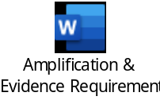 | Shows which pass and distinction descriptors need to be met through which assessment method, along with additional guidance of the evidence required.
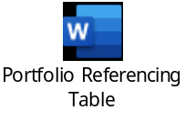 | This document must be used to map the Portfolio evidence to the descriptors and is submitted at gateway along with the Portfolio evidence.
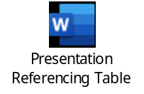 | This document must be used to map the Presentation materials to the descriptors and is submitted at the same time as the Presentation materials.

Further guidance documents which you may find helpful are available to download from the Support Materials sections of EPA Pro. These include:

- Policies and Procedures
- Templates – witness testimony, observation record, context statement etc.
- Technical requirements for assessment and Zoom/WebEx/Teams user guides
- EPA Pro user guide
- DSW Portfolio Requirements
- Appeals, Reasonable Adjustments, Special Considerations and Flexibilities Policy

Appendix III – Toolkit Amendments

V2 30.09.21
- V2.0 of Portfolio referencing table – removal of IEPA marking columns, added descriptor number.
- Clarification added around the IEPA setting the presentation title and time frames for this.
- Version 2.0 of the presentation title guidance to reflect the clarification on the title.
- Issue of PDF files not opening resolved.
- V2.0 of Presentation referencing table to include descriptor number.
- Planning meeting takes place once the refined title has been agreed.

V2.1 05.11.21
- V2.1 of Portfolio referencing table embedded – Unlocked column for Evidence Title and Location

V3 05.12.22
- Gateway section added to clarify the gateway requirements.
- Timeline infographic amended to show the EPA process in more detail.
- Reworded expectations for Presentation to clarify what is required.
- Simplified the process for setting the presentation title.
- Further guidance added to the resit and retake section.
- Amplification improved to offer further clarity to apprentices and training providers.
- Portfolio Referencing Table changed to a Word document so is more user-friendly.
- Presentation Referencing Table changed to a Word document so is more user-friendly.

This change is applicable to all apprentices who come through Gateway on or after 1 March 2023. Apprentices who come through Gateway before this date may still be assessed under this version as long as they are not disadvantaged.

The below documents have been updated to reflect the changes above. The version numbers are the current ones for the documents embedded within version 3 of the Toolkit:

Descriptor Mapping V3

Portfolio Referencing Table V3

Presentation Referencing Table V2.1

V3.1 18.01.23
- Descriptor Mapping document has been added to replace the preceding version. For each criterion, the relevant KSBs have been included.
- Portfolio Referencing Table document has been added to replace the preceding version. For each criterion, the relevant KSBs have been included.
- Presentation Referencing Table has been added to replace the preceding version. For each criterion, the relevant KSBs have been included.

As these changes have been made to provide clarity, it is recommended that these versions are used for all apprentices.

The version numbers below are the current ones for the documents embedded within version 3.1 of this Toolkit:
Descriptor Mapping V4.1
Portfolio Referencing Table V3.1
Presentation Referencing Table V2.2

V3.2 14.03.23
- Portfolio Referencing Table document has been added to replace the proceeding version. Details table has been added to the top of the document for learners to provide their name, ULN and name of the training provider. Edits to the formatting of contents have also been made.
- Presentation Referencing Table document has been added to replace the proceeding version. Details table has been added to the top of the document for learners to provide their name, ULN and name of the training provider. Edits to the formatting of contents have also been made.

As these amends have been made to allow the learner to provide their details, it is recommended that these versions are used for all apprentices with immediate effect.

The version numbers below are the current documents embedded within version 3.2 of this toolkit:
- Portfolio Referencing Table V3.2
- Presentation Referencing Table V2.3

V3.3 07.11.23
- Removal of the 2-page limit on notes an apprentice can bring with them to their Professional Discussion assessment.

The above amendment applies to all apprentices with immediate effect as of 07/11/2023.

V3.4 26.03.24
- Embedding of new Amplification and Evidence Requirements document
- Additional guidance was added around the setting of the Presentation Title

The version numbers below are the current documents embedded within version 3.2 of this toolkit:
- Amplification and Evidence Requirements v1.0

The above amendments apply to all apprentices with immediate effect as of 26/03/2024.

V3.5 08.05.24
- Removal of the amplification/”What is required” section on the Portfolio Referencing tables
- Removal of the amplification/”What is required” section on the Presentation Referencing tables.

The new referencing tables apply to all apprentices whose gateway date is on or after 01/08/2024.

Apprentices are permitted to use the new versions sooner, should they wish.

