




Coaching Professional
Level 5
Toolkit




Contents
Introduction 2
Gateway 2
End-Point Assessment Overview 3
Planning Meeting 3
Conditions for Assessment 3
Observation with Questions and Answers (Q&A) 4
Format of the assessment 4
The Observation 4
The Q&A 5
Assessment Method 2: Interview supported by Portfolio of Evidence 5
Portfolio of Evidence 5
Interview 6
Assessment Method 3: Knowledge Test 7
Grading 8
Observation with Q&A 8
Portfolio-Based Interview 8
Knowledge Test 8
Overall Grading 8
Re-sits and Re-takes 9
Appendix I – Supporting Documents 10
Appendix II – Mock Questions 11
Mock Interview Questions 11
Mock Q&A Questions 11
Appendix III – Toolkit Amendments 12
Version 1.2 – 28/02/2022 12
Version 2 – 06/04/2022 12
Version 2.2 – 26/10/2023 12
Version 2.3 – 20/11/2023 12
Version 2.4 – 08/03/2024 13

Introduction
DSW is your end-point assessment organisation for this apprenticeship. We have created this toolkit to help the apprentice, the apprenticeship training provider (ATP) and the employer to understand what is needed to successfully complete end-point assessment (EPA) for this apprenticeship standard.

All approved end-point assessment organisations must carry out EPA in line with the Coaching Professional Assessment Plan published by the Institute for Apprenticeships and Technical Education (IfATE). The Assessment Plan details the assessment methods used, the criteria to be assessed and the environment in which the assessments must take place.

The requirements and content of this toolkit come directly from the Coaching Professional Assessment Plan. You can download a copy of this from the IfATE website: https://www.instituteforapprenticeships.org

Gateway
Apprentices must be on-programme for a minimum of 12 months before they come through gateway and enter the EPA phase of the apprenticeship. The apprentice, employer and training provider must agree that the apprentice is demonstrating competence against the standard's knowledge, skills, and behaviours (KSBs).

Once an apprentice is ‘gateway-ready’, the training provider must submit the following to DSW’s epaPRO portal for approval:
- Gateway Declaration
- Proof of Level 2 maths and English
- Portfolio of evidence with completed referencing table

More information on acceptable gateway evidence and the form to be submitted can be found on epaPRO under Support Materials > Gateway Documents.

If any of these requirements are not met, gateway will not be approved.

End-Point Assessment Overview
The EPA will typically be completed over three months after the apprentice has met the EPA gateway requirements.

The Coaching Professional EPA consists of three assessment methods which can be completed in any order:

- Observation with Questions and Answers (hereafter referred to as the Observation)
- Interview supported by the Portfolio of Evidence (hereafter referred to as the Interview)
- Knowledge Test

The Observation and Interview are assessed by individual pass and distinction criteria, as per the table below:

Assessment Methods | Pass Criteria | Distinction Criteria
Observation with Questions and Answers | 8 | 5
Interview supported by Portfolio of Evidence | 6 | 3

There are an additional nine knowledge criteria which are mapped to the Knowledge Test.

The KSB Mapping document in Appendix I details which specific criteria must be met for each assessment method.

Planning Meeting
Following gateway approval, DSW’s Independent End-Point Assessor (IEPA) will make contact with the ATP to introduce themselves and arrange contact with the apprentice. The IEPA and apprentice will agree on the date(s) for the Observation and the Interview – this is typically agreed upon in an online planning meeting or via email. ATPs can also be involved in the booking process if requested.

The Observations and Interview can occur on the same day, with the option to have a break in between. The apprentice can book their online Knowledge Test on a date of their choosing.

The assessor will then confirm these dates in epaPRO and book the meetings on the agreed upon video conferencing platform.

Conditions for Assessment
All end-point assessments must be undertaken under examination conditions. It is essential that apprentices familiarise themselves with DSW’s Conditions for Live Assessment (available on epaPRO). The document sets out the mandatory requirements to ensure a secure and appropriate assessment environment, including apprentice ID requirements, panning of rooms and appropriate use of technology.

Failure to comply with DSW’s Conditions for Live Assessment may result in delayed, cancelled or failed assessments.

Observation with Questions and Answers (Q&A)

Format of the assessment
The apprentice is required to conduct two one-hour coaching sessions whilst being observed by the IEPA. The sessions must be delivered to different individuals and must be completed within one working day (typically 7.5 hours). It is recommended that the apprentice have a backup coachee available where possible in case of cancellation.

Following the coaching sessions, the apprentice and IEPA will take part in a 20-minute Q&A where the IEPA will ask the apprentice a series of questions based on their observation of both sessions.

Across the two coaching sessions, the apprentice should attempt to demonstrate all of the pass criteria assigned to this assessment method. They may also choose to attempt to meet the distinction criteria.

The Observation is not a simulation, therefore staged activities should not take place. Apprentices should ensure that they have permission from their coachees for the IEPA to observe and record the session.

Assessment environment
The coaching sessions can take place in any of the following environments:

- Face-to-face in the apprentice’s workplace
- Face-to-face in the coachee’s workplace
- Virtually, with both the apprentice and coachee fully visible throughout the session
- Any other appropriate venue agreed upon in advance by DSW

The IEPA will join the coaching sessions remotely, using the video conferencing platform agreed upon during the EPA planning meeting. Employers and ATPs should contact DSW if they would like to arrange for the IEPA to be physically present during the sessions.

For each coaching session, before the coachee arrives, the IEPA and apprentice will first join the call for a short ‘housekeeping’ session. This will include introductions, an overview of the assessment process and checks to ensure the conditions for assessment will be met (see ‘Conditions for Assessment’ in Appendix I). It is essential, for example, that the apprentice is in an appropriate environment and that they have their photographic ID with them.

Following the housekeeping activity, the apprentice will invite the coachee to join the session and brief introductions will be given. The IEPA will remind the apprentice and coachee that the session is being recorded before turning off their camera for the duration of the observation.

During the coaching sessions, the IEPA will simply observe the apprentice; they will not question or interrupt them. Both the apprentice and coachee must be fully visible throughout the session.

The apprentice is permitted to take notes during the observation.

The Observation
The activity being observed during the observation must be the delivery of coaching sessions with an individual receiving the coaching. This must be two one-hour sessions with two different individuals receiving the coaching. The Observation with Q&A will be scheduled for a time when the apprentice will be in their normal place of work. Video conferencing technology will be used to conduct the Observation and Q&A.

The apprentice should plan to make each coaching session last the full 60 minutes, but will not be penalised if either session finishes early. If a session overruns, the IEPA will not assess anything beyond 66 minutes.

There are elements of some criteria which must be demonstrated in the Observation rather than the Q&A (e.g. use of coaching models). Apprentices should familiarise themselves with the criteria they must cover and keep these in mind during the coaching sessions. The KSB Mapping Document in Appendix I details which criteria can only be demonstrated in the Observation, and which elements may be questioned in the Q&A.

The full coaching sessions must be recorded. For confidentiality reasons, the sessions must be set up as separate calls. You must capture the introduction and identification of the apprentice each time a new recording starts.
Whilst the apprentice is conducting the coaching sessions, the IEPA will mark them against the pass and distinction criteria assigned to this assessment method. They will be unobtrusive and not question or hinder them in any way.

The Q&A
The Q&A between the apprentice and IEPA will take place after the final coaching session has been completed and will last for 20 minutes.

A 10-minute break is allowed between the final observation and Q&A to allow time for the IEPA to finalise the questions to be asked in the Q&A.

The Q&A will comprise a minimum of five questions. Up to two follow-up questions may be used per initial question for the apprentice to provide further clarification. The questions will be selected based on the following:

- Any pass criteria not seen in the Observation
- Any distinction criteria not seen in the Observation
- Validation of observed activities

Example questions can be found in Appendix II.

DSW will issue the grade for this assessment within five working days of the Observation with Q&A.

Assessment Method 2: Interview supported by Portfolio of Evidence

Portfolio of Evidence
Whilst on-programme, the apprentice must compile a Portfolio of Evidence with examples of work they have completed throughout their apprenticeship. The Portfolio must be submitted at gateway and cannot be amended or added to once submitted.

The Portfolio must contain evidence mapped to all of the pass descriptors which are assigned to this assessment method. In addition, the apprentice may also choose to map their evidence to the distinction descriptors. The Portfolio will typically contain a minimum of 10 and a maximum of 15 pieces of evidence. Each piece of evidence may map to more than one descriptor. A piece of evidence may be a single document, or it may be a folder containing several documents which link together (for example, an email trail with associated attachments or related documents).

Portfolio evidence might include:

- observation reports
- anonymised written examples of coaching sessions the apprentice has completed
- feedback from managers, supervisors, or peers
- emails between the coach and coachee
- recordings or transcripts of coaching sessions. Video/audio extracts must be timestamped within the referencing table and be a typical maximum duration of 60 minutes.

This is not a definitive list; other evidence sources are allowable.

The Portfolio itself is not graded but is used to inform the questioning for the Interview. No feedback will be given to the apprentice ahead of the Interview.

Reflective accounts and self-evaluation cannot be included as evidence, except in relation to pass criterion P14. However, apprentices are encouraged to include written narratives or case studies to describe work situations they have been involved in and provide context to their evidence. DSW provides a Context Statement template which may be used for this purpose.

More information on compiling a portfolio can be found in the Portfolio Requirements document, available on epaPRO.

The apprentice must submit the Portfolio Referencing Table (Appendix I) along with their Portfolio at gateway. The apprentice should map their evidence to specific criteria in column D. There is additional guidance within the Referencing Table to support the apprentice with their mapping.

Appendix I of this toolkit provides a link to DSW’s Portfolio Requirements guide, which provides important information on how to structure, present and map Portfolio evidence.

Interview
A structured Interview will take place between the apprentice and the IEPA, testing the examples provided in the apprentice’s Portfolio of Evidence.

The apprentice may bring notes and a copy of their Portfolio to the Interview for reference. It is strongly recommended that apprentices review the content of the Portfolio before the Interview to make it easier for them to refer to it during the assessment.

The Interview must take place in a suitable environment, free from interruption. It will be delivered via an online video conferencing platform such as Webex or Zoom, as agreed between the apprentice and IEPA. It is strongly recommended that the platform is tested before the date of assessment to avoid technical problems and ensure familiarity. Employers and ATPs should contact DSW if they’d like to arrange for the Interview to take place face-to-face.

Apprentices must refer to DSW’s Conditions for Live Assessment (see Appendix I) to ensure that they are fully compliant with the environmental and technical requirements for the assessment.

The Interview will last 60 minutes (+10% at the discretion of the IEPA to allow the apprentice to complete their last answer).

The Assessor will ask nine open questions relating to evidence seen in the Portfolio. Up to two follow-up prompts per initial question may be asked where clarification is required.

Example questions can be found in Appendix III.

Following the Interview, the IEPA will finalise their assessment decision and will issue the final grade and summative feedback to the ATP. This will be done via the assessment record and issued within five working days of the assessment date.

Assessment Method 3: Knowledge Test
Apprentices will undertake a Knowledge Test which tests the nine knowledge criteria mapped to this assessment method.

The Knowledge Test will take place online and will be monitored by a remote invigilator. Apprentices will have 90 minutes to complete the assessment.

The test will be made up of 40 multiple-choice questions as follows:

- 30 multiple-choice questions that will have four possible answers, one of which will be correct
- 10 multiple-choice questions which will be based on two given scenarios; 5 questions will be asked per scenario which will still require the apprentice to select 1 option from a choice of 4.

The Knowledge Test will be delivered online using a web-based platform called QuestionMark. Apprentices will be provided with a user guide and login details when gateway has been approved. This will allow the apprentice to attempt the mock test and familiarise themselves with the platform. The apprentice is responsible for selecting the date of their live exam on the platform.

The Knowledge Test is closed book and will be conducted under examination conditions.

Results will be available within five working days of the test.

As well as the online mock test, the apprentice may use the paper-based mock in Appendix I to prepare for the live test. This will need to be marked using the answer sheet provided.

Grading

Observation with Q&A
To achieve a pass for this assessment method the apprentice must meet all eight pass criteria.

To achieve a distinction for this assessment method, in addition to the pass criteria the apprentice must meet all five distinction criteria.

Portfolio-Based Interview
To achieve a pass for this assessment method the apprentice must meet all six pass criteria.

To achieve a distinction for this assessment method, in addition to the pass criteria the apprentice must meet all three distinction criteria.

Knowledge Test
To achieve a pass for this assessment method, the apprentice must answer 26-34 questions correctly.

To achieve a distinction for this assessment method, the apprentice must answer 35+ questions correctly.

If the apprentice answers fewer than 26 questions correctly, this will result in a fail of the Knowledge Test.

Overall Grading
There are three levels of outcome for this standard: fail, pass and distinction.

To achieve an overall pass for the apprenticeship, the apprentice must achieve a minimum grade of a pass in each assessment method.

To achieve an overall distinction for the apprenticeship, the apprentice must receive a grade of distinction in all three assessment methods.

Re-sits and Re-takes
Apprentices who fail one or more assessment methods will be offered the opportunity to take a re-sit or a re-take of the failed assessment. A re-sit does not require further learning, whereas a re-take does.

If the apprentice fails the Observation, they will need to be observed carrying out two new coaching sessions and will be asked a different set of questions during the Q&A.

If the apprentice fails the Knowledge Test, they will be given a different set of multiple-choice questions for the re-sit or re-take.

If the apprentice fails the Interview, they will be given a different set of Interview questions for the re-sit or re-take.

Any assessment method re-sit or re-take must be taken within three months of the fail notification, otherwise, the entire EPA must be taken again.

Re-sits and re-takes are not offered to apprentices wishing to move from a pass to distinction.

Where any assessment method must be re-sat or re-taken, the apprentice will be awarded a maximum EPA grade of pass, unless DSW determines there are exceptional circumstances requiring a re-sit or re-take.

Appendix I – Supporting Documents
Document | Description
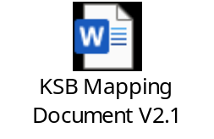 | This document details which KSB statements are assessed by each assessment method and details the criteria which must be met for each.
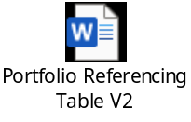 | The apprentice must submit the Portfolio Referencing Table along with their portfolio at Gateway. The apprentice should map their evidence to the specific criteria it relates to.
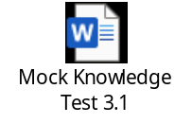 | The apprentice can use the paper-based mock Knowledge Test to prepare for the live test. This test contains the same questions as the mock Knowledge Test available on QuestionMark.
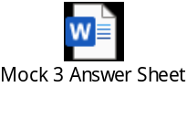 | The apprentice/ATP can mark the mock Knowledge Test using this answer sheet.

Further guidance documents which you may find helpful are available to download from the Support Materials sections of epaPRO. These include:

- Policies and Procedures
- Conditions for Live Assessment
- Templates – witness testimony, observation record, context statement etc.
- Technical requirements for assessment and Zoom/WebEx/Teams user guides
- epaPRO user guide
- DSW Portfolio Requirements
- Appeals, Reasonable Adjustments, Special Considerations and Flexibilities Policy

Performance-based evidence may take the form of witness statements or observations from credible people, such as a line manager, which confirm that the account provided by the apprentice in the anecdotal evidence is accurate and consistent with their performance in that situation.

Appendix II – Mock Questions

Mock Interview Questions
- In your coaching practice, how do you ensure cultural sensitivity and inclusivity when working with clients from diverse backgrounds?
- Describe a coaching relationship that required you to adapt your style or approach to meet the unique needs of the coachee. What strategies did you employ, and what were the results?
- How do you maintain professional boundaries and ethical practices in your coaching relationships?

Mock Q&A Questions
- How did you handle any resistance or challenges that arose during the coaching session?
- Describe a specific coaching model or technique you utilised during the session and explain its purpose and impact.
- How did you establish rapport and build trust with the coachee during the coaching session?

Appendix III – Toolkit Amendments

Version 1.2 – 28/02/2022
- Amendment made to amplification for criteria Pass 11 in the mapping document and referencing table.

The below documents have been updated to reflect the changes above. The version numbers are

the current ones for the documents embedded within version 1.2 of the Toolkit:
- KSB and Mapping Criteria V1.2
- Portfolio Referencing Table V1.2

Version 2 – 06/04/2022
- Updated mock test and answer sheet.

The below documents have been updated to reflect the changes above. The version numbers are

the current ones for the documents embedded within version 2 of the Toolkit:
- Mock Knowledge Test V3.0
- Mock Answer Sheet V3.0

Version 2.1 – 10/06/2022

- Updated mock test and answer sheet.

The below documents have been updated to reflect the changes above. The version numbers are
the current ones for the documents embedded within version 2.1 of the Toolkit:
- Mock 2 Knowledge Test V1
- Mock 2 Answer Sheet V1

Version 2.2 – 26/10/2023
- Questions asked during Q&A changed from 5 to ‘a minimum of 5’ to allow more flexibility to cover all areas required.
- Clarified that the assessor will switch off their camera once introductions have been done during the Observation.
- Amplification updated for clarity:
- Amplification for all descriptors amended. We have updated the amplification to confirm exactly what will be covered in the observation vs the Q&A and to what level of detail.
- The amplification for this assessment method has been split into ‘During the observation’, ‘During the Q&A’ and ‘Points to consider’,
- Minor wording changes throughout for clarity. For each descriptor, we have confirmed what is required to pass or what would constitute a fail, and what will be covered in the observation vs the Q&A.
- We have defined non-directive feedback for P6.
- P11: clarification on how apprentices with limited stakeholder interaction might approach this descriptor.
- Knowledge test: amplification for all descriptors amended. For every descriptor, we have specified which models are covered and to what level of detail. E.g., rather than ‘Kolb’ we have stated that apprentices should be able to identify each stage of Kolb’s Four-Stage Learning Cycle.
- The apprentice will not be penalised if the EPA period extends beyond three months.
- New sample questions added.
- New mock test and answer sheet added.

The below documents have been updated to reflect the changes above. The version numbers are the current ones for the documents embedded within version 2.1 of the Toolkit:
- KSB Mapping Document V2.0
- Mock 3 Knowledge Test
- Mock 3 Answer Sheet
- Portfolio Referencing Table V2

Version 2.3 – 20/11/2023
- Branding has been updated to the most recent version (front and back page). No changes have been made to the content of this Toolkit.

Version 2.4 – 02/04/2024
- Updated mock test.
- Question 7 replaced
- Question 11 reworded for clarity
- Question 18 replaced
- Question 29 replaced
- Video/audio extracts within the portfolio must be a typical maximum duration of 60 minutes.
- The Care Act 2014 replaces the Mental Health Act 1983 in the Knowledge Test.

The above changes are applicable to apprentices who come through gateway on or after

12/07/2024. Apprentices who come through gateway before this date may also be assessed

under this version if they will not be disadvantaged. This should be discussed with the IEPA during the planning meeting.

The below document has been updated to reflect the changes above. The version numbers are

the current ones for the documents embedded within version 2.4 of the Toolkit:
- Mock Knowledge Test 3.1
- KSB Mapping Document V2.1







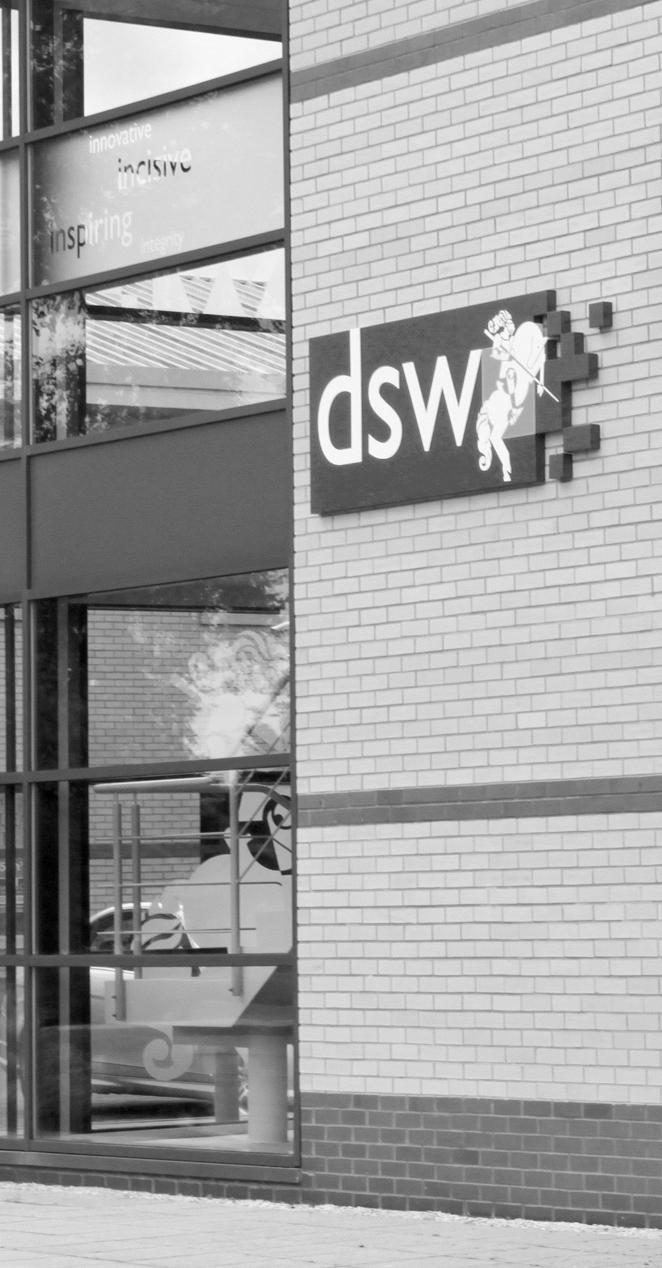
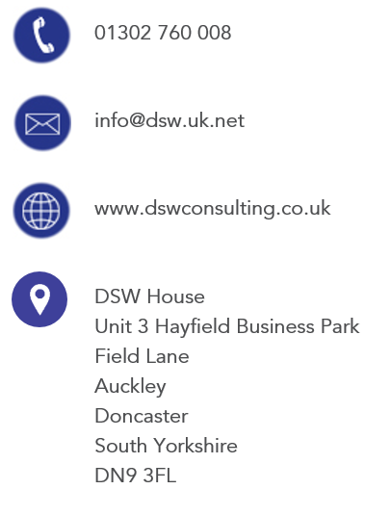
01302 760 008

EPA@dswlearning.co.uk

www.dswconsulting.co.uk

DSW House
Unit 3 Hayfield Business Park
Field Lane
Auckley
Doncaster
South Yorkshire
DN9 3FL

Doran Scott Williams & Co Ltd
©DSW 2024
All rights reserved. No part of this publication may be reproduced, stored in a retrieval system or transmitted in any form or by any means, electronic, mechanical, photocopying, recording or otherwise without the prior written permission of the publisher, DSW. This brochure may not be lent, resold, hired out or otherwise disposed of by trade in any binding or cover than that in which it is published, without prior consent from DSW. The law of copyright and its related rights in the UK applies and can be found in the copyrights sections in the Copyrights, Designs and Patents Act 1998 (as amended). Company Registered in England No 03803848

