Theories of Emotional Intelligence (K
Self-Awareness (B2)
Self-awareness, including of their own behaviours, values, beliefs and attitudes, and attending to their own wellbeing, resilience and maintaining mental capacity.
Print this page and complete the activities- these do not need to be submitted, they are simply for your own reflection.
- Start by picking 10 words that resonate as core values. Then narrow that down to 5. You can choose your own if you wish.
Accountability  Achievement  Adaptability  Adventure  Altruism  Ambition  Authenticity  Balance  Beauty  Being the best  Belonging  Career  Caring  Collaboration  Commitment  Community  Compassion  Competence  Confidence  Connection  Contentment  Contribution  Cooperation  Courage  Creativity  Curiosity  Dignity  Diversity  Environment  Efficiency  Equality  Ethics  Excellence  Fairness  Faith  Family  Financial stability  Forgiveness  Freedom  Friendship | Fun  Future generations  Generosity  Giving back  Grace  Gratitude  Growth  Harmony  Health  Home  Honesty  Hope  Humility  Humour  Inclusion  Independence  Initiative  Integrity  Intuition  Job security  Joy  Justice  Kindness  Knowledge  Leadership  Learning  Legacy  Leisure  Love  Loyalty  Making a difference  Nature  Openness  Optimism  Order  Parenting  Patience  Patriotism  Peace  Perseverance | Personal fulfilment  Power  Pride  Recognition  Reliability  Resourcefulness  Respect  Responsibility  Risk-taking  Safety  Security  Self-discipline  Self-expression  Self-respect  Serenity  Service  Simplicity  Spirituality  Sportsmanship  Stewardship  Success  Teamwork  Thrift  Time  Tradition  Travel  Trust  Truth  Understanding  Uniqueness  Usefulness  Vision  Vulnerability  Wealth  Well-being  Wholeheartedness  Wisdom

Self-Awareness (B2)
Self-awareness, including of their own behaviours, values, beliefs and attitudes, and attending to their own wellbeing, resilience and maintaining mental capacity.

2. Complete the Wheel of Life by scoring your satisfaction levels against each of the categories. Do this by colouring up to that line.

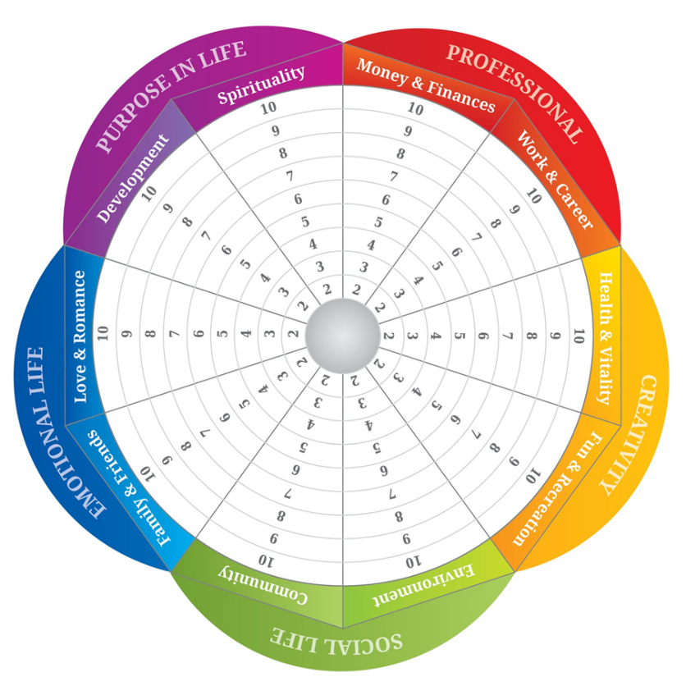

3. Now look at your values and compare this to your wheel (you can even plot the values into the different sections of the wheel if you wish). Are your values in alignment with your current way of life?
4. Consider these questions:
What area of your life is currently giving you the most satisfaction? How do you know? How is this in alignment with your values?
What are of your life is giving you the least satisfaction? Why do you think this is? How do you know?
What one action could you take to improve this area of your life?

